

الجمهورية العربية السورية
وزارة التعليم العالي والبحث العلمي
الجامعة السورية الخاصة

Design and implementation of a secure network from one site to another
تصميم وتنفيذ شبكة آمنة من موقع إلى آخر
تخصص هندسة امن النظم والشبكات الحاسوبية مشروع تخرج 1

الاعداد :
يزن ماجد شيخوني
ابراهيم تحسين الرمضان

الاشراف
م.فراس خير بك

Index :
the Introduction : 5
1.1 Chapter One: Theoretical Study 9
1.1.1 Section 1: General Introduction to MPLS 10
1.1.2 The basic principle of MPLS operation and its technical details: 11
1.1.3 The basic components of an MPLS network and their functional roles: 13
1.1.4 Basic naming processes in MPLS and implementation mechanisms: 14
1.1.5 Label distribution protocols and coordination mechanism: 15
1.1.6 MPLS VPN services and their different types: 16
1.1.7 Traffic Engineering in MPLS : 18
1.1.8 Quality of Service (QoS) in MPLS networks: 20
1.1.8 A comprehensive comparison between MPLS and traditional networks: 21
1.1.10 The future of MPLS and recent technological developments: 22
2.1 Chapter Two: The Work Environment 33
2.1.1 Chapter Introduction: 33
2.1.2 Simulation Tools: 34
OPNET Modeler 14.5: 34
OPNET Modeler version 14.5 was used. It is one of the most powerful and accurate network simulation tools used in academia and research. The software provides: 34
Accurate models of routers, switches, and links. 34
Full support for OSPF, MPLS, LDP, and QoS protocols. 34
The DES (Discrete Event Simulation) engine for simulating packet traffic in real time. 34
3.1 Chapter Three: Proposed Solution 43
4.1 Chapter Four: Comparisons and Analysis 70
4.1.1 Analysis of Achieved Results 71

Index of Figures:
Figure 2.1 Project Diagram: ……………………………….……………………………………...34
Figure 3.1 Ping DES successfully sent and received…………………………………………….43
Figure 3.2 Router ID same as loopback IP for each router…………………………………….44
Figure 3.3 Specify the Area ID……………………………………………………………………….45
Figure 3.4 General attributes configuration………………………………………………………..46
Figure 3.5 Enable MPLS and LDP………………………………………………………………….47
Figure 3.6 ICMP messaging from node 8 to node 9…………………………………………...48
Figure 3.7 IP addressing + linkup and operational + routing OSPF…………………………..49
Figure 3.8 IP routing sync MPLS LDP in the interfaces info…………………………………..50
Figure 3.9 Loopback Interfaces addressing + routing OSPF…………………………………….51
Figure 3.10 OSPF DES showing successful convergence for node 8…………………..…….52
Figure (3.11): Traffic Mapping Configuration – FEC Specifications on node…………….…...55
Figure (3.12): MPLS and Traffic Engineering Attributes on node_8 (Router)………………...56
Figure (3.13): Traffic Mapping Configuration – Interface to FEC Assignment on node_8…...57
Figure (3.14): RSVP-TE Configuration on Interface IF0 of node_8……………………………..58
59………………….Figure (3.15): QoS Configuration – WFQ Profile for MPLS-TE on node_8
Figure (3.16): Capturing LSP Flows and Traffic Statistics………………………………………..60
Figure (3.17): VoIP Packet Simulation After MPLS-TE Activation……………………………...61
Figure (3.18) : Delay on Primary Link……………………………………………………………62
Figure (3.19) : Delay on Secondary Link After MPLS-TE Activation………………………63
Figure (3.20) : Primary LSP Flow Traffic Between node_8 and node_9………………….64
Figure (3.21) : Secondary LSP Flow Traffic Between node_8 and node_9……………..65
Figure (3.22) : RSVP Path Messages Received on node_9………………………………..66
Figure (3.23) : RSVP Path Messages Sent from node_8…………………………………..67
Figure (3.24) : Throughput on Link Between node_7 and node_9…………………………68
Figure (3.26) : Traffic Sent and Received on Primary Link………………………………….69
Figure (3.27) : IPsec Encryption Algorithm Configuration (AES)……………………………70
Figure (3.28) IPsec Transform Set Configuration (ESP Tunnel Mode)…………………….71
Figure (3.28) IPsec Transform Set Configuration (ESP Tunnel Mode)…………………….72
Figure (3.29) IPsec Tunnel Establishment and Peer Configuration…………………………73
Figure (3.30) : IKE Policy and Pre-shared Key Configuration………………………………74
Figure (3.31) : Overall IPsec-Encrypted Traffic Results………………….……………..…..75

the Introduction :
Multiprotocol Label Switching (MPLS) is one of the most significant technological innovations that has transformed global data networks over the past two decades. This advanced technology emerged in the late 1990s as a practical solution combining the advantages of Layer 2 (Data Link Layer) switching and Layer 3 (Network Layer) routing speeds within the seven-layer OSI model. MPLS operates on the principle of using numerical labels instead of long and complex IP addresses to route data packets across the network, significantly reducing processing time at routers and increasing overall network efficiency.
With the significant expansion of the use of the internet in applications such as audio editing and cloud output, there is a growing need for advanced technologies that not only ensure speed but also control traffic, guarantee quality of service (QoS), and precisely engineer routes. This is where MPLS-TE comes in, enabling dedicated routes and engineering for specific data types, identifying congestion zones, and ensuring balanced competition across different links.
Furthermore, information security in networks has become one of the most significant challenges facing organizations and companies in the digital age. Data leaks and cyberattacks (such as denial-of-service attacks, address spoofing, and DNS poisoning) are now a daily reality. Therefore, the IPsec (Internet Protocol Security) protocol has been integrated into this project to provide a robust encryption layer (AES-256) that ensures the confidentiality and integrity of data transmitted between the two sites, even if intercepted by unauthorized parties.
The idea for this project stemmed from the need to understand how these advanced technologies work practically and practically, and to test their setup and implementation on network devices (both virtual and physical) to achieve a comprehensive model similar to those used in large organizations and companies. A complete working environment was created on the VMware platform to simulate network devices and run multiple systems simultaneously without the need for expensive physical equipment. MikroTik CHR (Cloud Hosted Router) devices were used as they are suitable for implementing advanced routing technologies and fully support MPLS, LDP, OSPF, QoS, and IPsec protocols.
Our approach involved setting up each virtual site as an independent network, then connecting them using MPLS-TE with two engineered paths (primary and secondary). We implemented strict QoS policies prioritizing Voice over Internet Protocol (VoIP) traffic over regular data traffic, and finally, encrypted the entire connection between the two sites using IPsec. This experience helped us learn the steps involved in setting up integrated networks from scratch, starting with creating virtual routers, configuring OSPF routing protocols, enabling MPLS, QoS, and IPsec, and monitoring network performance after connection.

Project objective:
Building a Flat MPLS Infrastructure:
Establish an end-to-end MPLS network between two sites using MikroTik CHR devices in a VMware environment.
Configure physical and logical (loopback) interfaces and assign static and logical IP addresses to each site.
Enabling Dynamic Routing with OSPF: Configure OSPF (version 2) on all routers (edge ​​nodes LERs and core nodes LSRs).
Set all interfaces to a single backbone area (Area 0.0.0.0) to ensure full path visibility and rapid convergence.
Verify that all routers have reached full neighborhood status.
Enabling Label Exchange via MPLS and LDP: Enable MPLS on the WAN interfaces dedicated to connecting the two sites.
Enable the Label Distribution Protocol (LDP) to automatically generate a Label Information Table (LIB) and a Label Forwarding Table (LFIB). Verify successful LDP sessions between all LSR devices.
Implement traffic engineering (MPLS-TE) using RSVP-TE: Create two engineered tunnels (TE Tunnels): Primary tunnel: LER_A → LSR1 → LSR2 → LSR3 → LSR4 → LER_B

Secondary Path: LER_A → LSR5 → LSR6 → LSR7 → LSR8 → LER_B Configure RSVP-TE protocol to reserve the required bandwidth and ensure Quality of Service (QoS). Enable Load Balancing for normal data traffic between the two paths. Ensure Quality of Service (QoS) for critical applications: Classify traffic into two categories: VoIP (voice) with high priority, and Data (normal data) with lower priority. Implement Strict Priority Queuing (PQ) on each exit interface of the LSR and LER devices. Use the DSCP field in the IP header and the EXP Bits field in the MPLS header to transmit priority information between nodes. Secur the entire connection between the two sites using IPsec: Establish a secure IPsec tunnel between the LER_A and LER_B edge devices in Tunnel Mode (to fully encrypt the IP header). The system employs the robust AES-256 encryption algorithm and the SHA-256 authentication algorithm with the IKEv2 key exchange protocol.
This ensures that all traffic (VoIP and data) between the two sites is encrypted, rendering it unreadable upon interception.

1.1 Chapter One: Theoretical Study

1.1.1 Section 1: General Introduction to MPLS
Multiprotocol Label Switching (MPLS) is one of the most significant technological innovations that has transformed global data networks over the past two decades. This advanced technology emerged in the late 1990s as a practical solution combining the advantages of Layer 2 switching with the speed of Layer 3 routing in the seven-step OSI model.

MPLS was primarily developed to address the growing challenges related to data transmission speed and resource efficiency in wide area networks (WANs), especially with the rapid expansion of the internet and network applications. This unique technology operates on the principle of using digital labels instead of long and complex IP addresses to route data packets across the network, significantly reducing processing time at routers and increasing overall network efficiency. MPLS uniquely falls between Layer 2 and Layer 3 of the OSI model, making it independent of core protocols and capable of working with various network types and technologies without compatibility issues. Due to its high efficiency in managing data traffic and providing superior quality of service for diverse applications, MPLS has become the backbone of many service provider networks worldwide. This technology also offers advanced traffic engineering capabilities and QoS assurance, making it the ideal choice for critical applications such as voice, video, and other essential services.

MPLS has evolved from a simple transport technology into a comprehensive platform for advanced services, including VPNs, cloud services, and complex enterprise applications. Many financial institutions, government agencies, and large corporations rely on MPLS to seamlessly and reliably connect their branches across different geographic regions. Studies indicate that MPLS is used in more than 70% of major global carrier networks, confirming its leading position in the networking world. The technology continues to evolve to meet modern requirements such as cloud computing, the Internet of Things (IoT), and various smart applications.

1.1.2 The basic principle of MPLS operation and its technical details:
The core principle of MPLS operation relies on the concept of rapid label swapping instead of the complex searching through traditional routing tables based on long IP addresses. When a data packet enters an MPLS network via an edge device, it is assigned a digital label, similar to a smart postage stamp, which directs it along a predefined path based on specific policies. This label consists of 32 bits, precisely divided into several key parts: 20 bits for the unique identifier (label), which represents the primary routing value; 3 bits to identify the traffic class used for quality of service (QoS); 1 bit for the stack indicator; and 8 bits for Time to Live (TTL), which prevents packets from looping endlessly through the network.

Technically, the label is placed between the Layer 2 (Data Link Layer) and Layer 3 (Network Layer) headers of the data packet. This preserves the original structure of the IP packet while adding the necessary routing information. The technical strength of MPLS lies in the fact that each router along the path simply looks at the label and replaces it with a new one, directing the packet to the next router, without needing to parse the entire IP header at each node, thus saving valuable time. This intelligent mechanism significantly reduces latency and improves network performance in a measurable way.

MPLS works with various Layer 2 protocols such as Ethernet, ATM, and Frame Relay, making it truly multi-protocol. MPLS also supports label stacking, which allows multiple labels to be used simultaneously for advanced applications. This technical flexibility enables the creation of complex networks supporting multiple services on the same infrastructure. Understanding how labels work is fundamental to understanding how MPLS delivers speed and efficiency in long-distance data transmission.

1.1.3 The basic components of an MPLS network and their functional roles:
An MPLS network consists of several types of specialized devices that perform integrated and specific functional roles to ensure efficient and reliable network operation. Label Edge Routers act as strategic entry and exit points for the MPLS network, adding labels to incoming packets and removing them from outgoing packets according to predefined rules.
Within the core network, there are Label Switch Routers that transmit data using only labels, without directly handling IP addresses, thus simplifying routing. There are also Label Switched Paths, which are predefined paths, either dynamically or manually, that packets follow across the network from the entry point to the exit point.
In addition, there are Forwarding Equivalence Classes that group packets with similar characteristics and route them in the same way along the same path to ensure consistency. These core components work together harmoniously and synchronously to create an efficient and reliable network that supports multiple services and diverse requirements. There are also specialized subtypes of devices, such as Provider Edge Routers, that connect client networks to the provider network. The provider routers, which form the core of the provider network, and all these components interact via dedicated distribution protocols such as LDP and RSVP-TE to exchange label information and establish routes. Each device has its own tables, such as a Label Information Base and a Label Forwarding Information Base, for storing and processing label information. This precise functional division ensures optimal task allocation, maximizing the utilization of network resources.

1.1.4 Basic naming processes in MPLS and implementation mechanisms:
Data packets in an MPLS network undergo three main naming operations that precisely determine how they travel from source to destination across the complex network. The first operation is Push, or Add, where a new label is applied to the packet as it enters the MPLS network via an Ingress LER. This label determines the path the packet will take across the network. The second operation is Swap, or Replacement, where the old label is replaced with a new one at each point of entry within the network by LSRs, directing the packet to the next step in its path based on routing tables.
The third operation is Pop, or Removal, where the label is removed from the packet as it exits the MPLS network via an Egress LER, returning it to its original state before delivery to the final destination network. In addition to these basic operations, MPLS supports an advanced operation called Swap with Push to handle multiple labels on the stack for complex scenarios. These operations are performed very quickly using specialized hardware circuitry, minimizing processing time.
The implementation of these operations relies on efficient algorithms that determine the relationship between incoming and outgoing labels at each device. These mechanisms allow the creation of virtual paths independent of the underlying physical layer of the network. These processes can be programmed to support advanced policies such as quality of service and traffic engineering. The orderly sequence of these processes ensures efficient and highly reliable data transmission over long distances.

1.1.5 Label distribution protocols and coordination mechanism:
MPLS networks rely primarily on several specialized and integrated protocols for distributing and managing labels between different devices and coordinating their interactions. The most well-known of these protocols is the Label Distribution Protocol (LDP), which is the primary protocol used by devices to exchange label information and automatically create label swapping paths using existing routing tables.

There is also the Resource Reservation Protocol - Traffic Engineering (RSVP-TE), which is used to create engineered paths that reserve specific resources and ensure quality of service for sensitive applications such as voice and video. Additionally, Multiprotocol BGP (MP-BGP) is used in MPLS VPN networks to transmit routing information between different client sites across the shared provider network.
These protocols work together seamlessly to ensure that every device in the network knows the appropriate labels and how to handle them in various scenarios. LDP uses adjacency mechanisms to transmit label information directly between devices and establish reliable communication relationships. RSVP-TE supports the creation of one-way and two-way paths with guaranteed bandwidth and quality resource reservations.
MP-BGP distributes VPN information between PE devices while maintaining the isolation of different virtual networks. The coordination mechanism also includes assistance protocols to improve performance and reliability, such as BFD for rapid fault detection. This integrated system of protocols ensures the smooth operation of complex, multi-service MPLS networks.

1.1.6 MPLS VPN services and their different types:
Virtual Private Network (VPN) services are one of the most important and widespread real-world applications of MPLS. These advanced services are divided into two main types: MPLS L3 VPNs, which operate at Layer 3 (network layer), where routing information is exchanged between client sites across the provider's network using protocols like BGP; and MPLS L2 VPNs, which operate at Layer 2 (data link layer), making different sites appear to be connected to a single, unified local network.
MPLS VPN services provide complete isolation and advanced security between different clients using the same physical infrastructure, while maintaining the privacy and confidentiality of each client's data separately. MPLS VPNs are more efficient and secure than traditional VPN technologies because they use labels instead of complex tunnels.
MPLS L3 VPNs support two main models: the RFC 4364 model (formerly RFC 2547), which uses MP-BGP, and the Virtual Router model, which provides complete isolation between clients. MPLS L2 VPNs include technologies such as VPLS for Virtual Wide Area Networks and VPWS for Virtual Circuits. These services offer high flexibility in connecting remote branches and offices with high quality and cost-effectiveness. MPLS VPN enables organizations to expand their local networks across wide geographic areas without sacrificing performance or security.

1.1.7 Traffic Engineering in MPLS :
Traffic engineering is one of the most powerful and valuable features of MPLS technology. It allows for precise and advanced control over how data flows across a complex network. MPLS Traffic Engineering enables operators and engineers to define specific, customized paths for particular types of data and even individual applications, rather than relying solely on traditional short routing routes.
This advanced control allows for avoiding network congestion, distributing loads evenly across different links, and ensuring optimal quality of service for critical applications such as voice, video, and data.
The technology also allows for the creation of pre-configured backup routes that activate automatically and immediately upon any failure of the primary routes, ensuring uninterrupted service continuity and high reliability.
MPLS-TE uses the RSVP-TE protocol to send control messages and create engineered tunnels with the necessary resource allocation. It also supports Constraint-based Routing, which takes into account various constraints such as bandwidth, latency, and other requirements. These technologies allow for improved overall network resource utilization and reduced waste of available capacity. Advanced policies can be applied to prioritize specific types of data at peak times. These capabilities make MPLS the ideal choice for large networks that need intelligent management of complex traffic.

1.1.8 Quality of Service (QoS) in MPLS networks:
MPLS provides advanced and flexible QoS capabilities by integrating multiple mechanisms for classifying, categorizing, scheduling, and controlling traffic. Network traffic can be precisely categorized into different classes based on its requirements and importance levels, such as regular data, voice, video, and enterprise application-critical data. Each of these classes can be prioritized and behave differently in network congestion situations, ensuring that critical applications receive the necessary bandwidth and performance even under challenging conditions.
MPLS also enables the creation of engineered tunnels with guaranteed and predefined resource reservations, significantly improving real-time application performance. MPLS utilizes a 3-bit Experimental Bits field in the label header to carry QoS information between different devices. Technologies such as DiffServ-MPLS support the integration of DiffServ-based QoS systems with the core MPLS architecture. Multi-level policies can be applied to handle traffic at the application, user, or site level. These capabilities enable organizations to ensure consistent performance of mission-critical applications across the wide area network. These advanced capabilities make MPLS the ideal choice for companies that rely on advanced, performance-sensitive applications that require guaranteed and stable performance assurances.

1.1.8 A comprehensive comparison between MPLS and traditional networks:
MPLS clearly outperforms traditional IP-based networks in several critical aspects that impact network performance and reliability. In terms of speed and performance, MPLS significantly reduces packet processing time because devices handle simple labels instead of complex and lengthy IP addresses that require searching through large tables.
In terms of flexibility and adaptability, MPLS allows for the creation of customized and engineered paths for different types of data, whereas traditional networks rely only on short routing paths that may not be optimal. Regarding reliability and service continuity, MPLS provides faster and more efficient recovery mechanisms in the event of failures compared to traditional networks.
MPLS also offers a higher level of privacy and security by completely isolating the traffic of different clients on the same physical infrastructure. Although the initial cost of implementing MPLS is higher than traditional networks, its numerous long-term benefits make it a worthwhile investment for many large and medium-sized enterprises.
MPLS also supports advanced services such as VPN, QoS, and TE better than traditional technologies. Furthermore, MPLS offers greater scalability for organizations that anticipate future growth and expansion. MPLS also provides simplified management of complex networks compared to traditional, dispersed solutions.

1.1.10 The future of MPLS and recent technological developments:
The future of MPLS technology is clearly geared towards deep integration with cutting-edge technologies such as Software-Defined Networking (SDN), advanced cloud computing, and the Internet of Things (IoT). The evolution of MPLS-TP, specifically designed for the transport layer, is witnessing a significant expansion of MPLS applications to include traditional transport networks and advanced data centers.
MPLS security mechanisms are continuously improving through the integration of robust encryption protocols such as IPsec and MACsec to ensure comprehensive protection of transmitted data. Research and development are constantly enhancing MPLS scalability, making it more suitable for large-scale, high-performance networks. As enterprises increasingly rely on cloud applications and advanced digital services that demand high performance and unwavering reliability, MPLS will continue to play a pivotal role in global network infrastructure.
Experts anticipate that MPLS will evolve to support new services such as 5G private networks and edge computing. Working alongside emerging technologies, MPLS will provide comprehensive solutions for modern connectivity. It will maintain its position as a core technology while continuously adapting to the new requirements and emerging challenges of the rapidly evolving network landscape.

1.2 Introduction to IPSEC
With the rapid development of technology, the internet has become an indispensable tool in the modern age, serving as a global encyclopedia and a source of information across various fields of knowledge. However, it's worth noting—as studies show—that this network is not entirely secure, as current protocols contain vulnerabilities that can be exploited in various attacks, such as:
Denial-of-Service (DoS) attacks.
DNS poisoning.

IP spoofing.
To achieve network security, security protocols like SSL, SSH, and TLS are used. Among these protocols, IP Security Protocol (IPSec) stands out, having proven highly effective in providing protection, to the point that it has become a candidate to become the standard security protocol, a proposal previously put forward by US agencies. The primary objective of this chapter is to review the implementation of IPSec using the Ubuntu operating system, given its high flexibility in installing open-source code (such as OpenSwan).

1.2.1 Research Problem and its Importance
Information and data leaks on the world's largest network (the internet) have become a frequent and alarming reality. Millions of data sets have been compromised. Let's say a company has a massive database containing millions of users with their names, passwords, email addresses, and sensitive data. It might seem trivial if this data were handed over to someone who doesn't know what to do with it, but just as there are experts to defend the internet, there are also experts to attack it. These attackers are capable of:
Using thousands of email accounts to launch attacks on websites.
Sending emails containing viruses.
Using passwords and usernames to attempt to hack other websites.
Imagine that the data isn't limited to this type; it also includes:
Financial data.
Inventory data.
Products, objectives, and plans.
All this information, in the hands of someone who knows how to use it, becomes a goldmine.

1.2.2 Potential Forms of Security Breaches
Information destruction.
Information coding or misrepresentation.
Data theft, removal, or loss of resources.
Service disruption.
• Available Defense Technologies
Several defense technologies are available, including:
SSL (Secure Sockets Layer): Allows client/server applications to securely exchange information through authentication. SSL is widely used because its implementation complexity is moderate and it provides effective defense (Martins, 2009).
SSH (Secure Shell): Allows virtual access to a server via a terminal. It can be considered "secure telnet" because all communication is encrypted (Cybernetx, 2011).
VPN (Virtual Private Network): Point-to-point connections in private or public networks using tunneling protocols (Microsoft, 2014). Important note: Although IPSec requires a VPN to function, the two concepts are distinct and should not be confused, as one encompasses the other. This chapter focuses on the IPSec protocol as a case study.

Theoretical Framework:
In the early days of the internet, network security was not a major concern. While the internet was largely confined to scientific and academic circles, security issues were not a major concern due to the existence of ethical controls governing the use of network code (Huitema, 1998).
However, the internet expanded enormously, becoming the world's largest network and equipment constellation. The major step towards a heightened focus on network security began when the network was also extended to the private sector, leading to attacks and a diversification of targets.
IP Security (IPSec) is a security platform developed by the IP Security Protocol Working Group of the IETF (Internet Engineering Task Force) in response to network security challenges.
To understand the IPSec protocol, one must have a solid foundation of information about:
How computer networks work.
The communication between devices that use this protocol.

1.2.3 The Internet and Cryptography
The internet can be defined as a global network (a union of several smaller networks) capable of reaching even the most remote areas, thus establishing communication between all equipment within it regardless of distance (Tanenbaum, 2003).
Cryptography is defined as a combination of the Greek words "kryptos" and "graphene," meaning "hidden" and "writing," respectively (Romagnolo, 2007). Therefore, it is a set of rules that must be followed by both the sender and receiver so that a message can be sent from one end and understood by the other.
1.2.4 Virtual Private Networks (VPNs)
VPNs operate with point-to-point (P2P) connections, whether on private or public networks. This technology uses proprietary protocols based on TCP/IP, known as tunneling protocols. The idea is to simulate a real tunnel where only the sender and receiver know the connection.
• The motivation behind VPNs:

Security interests of large companies that need to communicate with their branches.
Ensuring that their data is not compromised while traveling across the network.
Cost reduction (instead of building a custom infrastructure for each company, the internet's existing infrastructure is used).
• How VPNs work:
Data is encapsulated with a header containing the necessary routing information. The transmitted data is encrypted, thus maintaining confidentiality.

1.2.5 IPSec Protocol in Detail
IPSec is a set of standards that can ensure secure communication between two computers, even if the information is transmitted over an insecure medium such as the internet (Battisti, 2013).
• Why IPSec?
It proves to be the most complete framework for use in VPNs.
It is treated as a reference by equipment manufacturers and may become a future standard (Martins, 2000).
The current IPv4 protocol lacks built-in security features. IPSec restricts communication to being possible only between devices on which it is enabled.

1.2.6 Key IPSec Features:
Multiple implementation options (from servers to routers and firewalls).
Can be integrated with TCP/IP.
Uses the Diffie-Hellman protocol for key exchange between device pairs.
Generally uses DES or 3DES encryption.
Uses MD5 or SHA-1 for packet authentication.
Uses digital certificates for key verification.

1.2.7 Conclusion
After practical implementation, the IPSec protocol proved its effectiveness in securing communication activities. Businesses can benefit from the reliability of this protocol in their communications. Insecure networks like the internet are no longer a concern for businesses when using IPSec, as it achieves all its intended objectives. This is why it is being chosen over other protocols to be the future standard.

Although IPSec might be seen as a temporary solution until IPv6 is fully implemented, this is not the case. IPSec is a robust solution in its own right. Even when IPv6 becomes the standard, IPSec will not be forgotten because it is already implemented within it, and the effort to understand it will still be necessary.

2.1 Chapter Two: The Work Environment

2.1.1 Chapter Introduction:
This chapter presents the environment used in the project "Design and Implementation of a Secure Cross-Site Network Using MPLS-TE with QoS and IPsec."
OPNET Modeler 14.5 was used as the primary simulation tool, relying on the DES (Discrete Event Simulation) module to analyze packet traffic at the core node level (LSR1-LSR8) and the edge nodes (LER_A and LER_B). The chapter aims to document the software environment, build the topology, activate the OSPF protocol across all nodes, and ensure full connectivity at the core router level to support MPLS-TE paths.

2.1.2 Simulation Tools:
- OPNET Modeler 14.5:
- OPNET Modeler version 14.5 was used. It is one of the most powerful and accurate network simulation tools used in academia and research. The software provides:
- Accurate models of routers, switches, and links.
- Full support for OSPF, MPLS, LDP, and QoS protocols.
- The DES (Discrete Event Simulation) engine for simulating packet traffic in real time.
2.1.3 DES (Discrete Event Simulation) Unit
Discrete Event Simulation (DES) was used to analyze network traffic, focusing on:
• The OSPF Hello packet exchange mechanism between core nodes.
• OSPF convergence time after a topology change.
• MPLS label tracking within packets traveling between sites.
• Measuring latency and packet loss when routing VoIP and regular data traffic.
2.2 Building the topology:
A network topology was created in OPNET, with separate interfaces added for VoIP and data:
Site A LAN: 172.168.10.0/24
Site B LAN: 172.168.20.0/24
WAN MPLS_VOIP: 10.0.0.0/28 (Voice Link)
WAN MPLS_DATA: 11.0.0.0/28 (Data Link)

Figure 2.1 Project Plan:
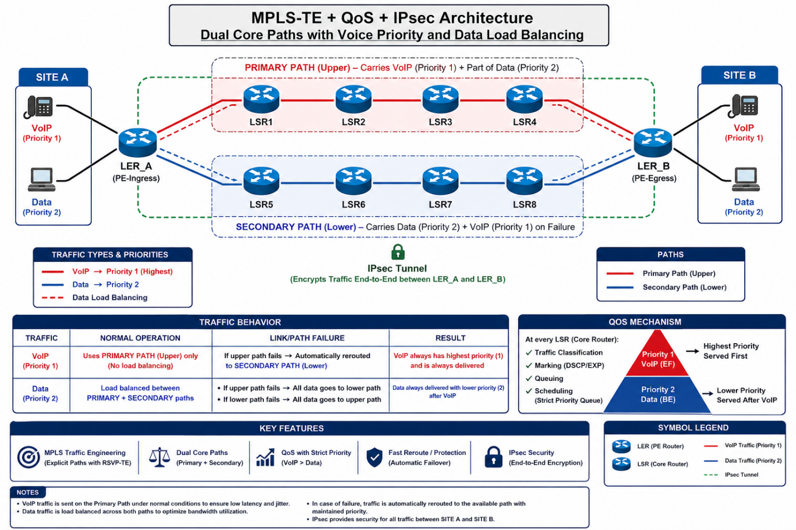
2.3 OSPF Protocol Settings:
2.3.1 Enabling OSPF on routers:
OSPF is enabled on all routers (SiteA_Router and SiteB_Router) within OPNET via the object properties as follows:
OSPF Process: Enabled
• Router ID:
SiteA_Router: 172.168.10.1
SiteB_Router: 172.168.20.1
• OSPF Zones:
All networks in area 0.0.0.0 (backbone)
Interface Type:
Broadcast (for LANs and MPLS)

2.4 MPLS and LDP settings:
MPLS was enabled on the MPLS_VOIP and MPLS_DATA interfaces of both routers, with LDP enabled as follows:
• MPLS Label Range: 16 – 1048575 (default)
• LDP: Enabled with an LSR ID equal to the Router ID
• LDP Hello is sent over the MPLS interfaces every 5 seconds. LDP functionality was verified by:
• Monitoring LDP discovery packets in the DES results.
• Ensuring the presence of a Label Table (LIB) for each interface.

2.5 QoS (Quality of Service) settings:
The Strict Priority Queuing mechanism was applied to both LSR and LER as follows:
Priority | type of movement | Procedure
1 (top) | VoIP | It is served first, and takes a guaranteed 5 Mbps bandwidth reservation on the primary route.
2 | Data | It is served after VoIP, and distributed between the two paths (Load Balancing)
The following were used:
DSCP Marking: EF for VoIP, AF13 for data.
EXP bits in the MPLS header for transmitting priority information between LSRs.
Queuing: PQ (Priority Queuing) on ​​each exit interface.

2.6 IPsec encryption settings:
An IPsec tunnel was established between LER_A and LER_B to encrypt all traffic (VoIP + Data) between the two sites.
Tunnel characteristics:
• Protocol: ESP (Encapsulating Security Payload)
• Encryption: AES-256
• Authentication: SHA-256
• Mode: Tunnel mode (for full IP header encryption)
• Key Exchange: IKEv2 The functionality of IPsec was verified by:
• Monitoring ESP packets in DES results.
• Ensuring that packets between LER_A and LER_B are unreadable without a key.

2.7 OSPF protocol settings on all core routers:
- • OSPF is enabled on LER_A, LER_B, and all LSRs (1-8). OSPF is enabled on all routers (10 nodes) within OPNET via the properties of each object as follows: OSPF Process: Enabled Router IDs (Example):
• LER_A: 172.168.10.1
• LER_B: 172.168.20.1
• LSR1: 1.1.1.1
• LSR2: 2.2.2.2
• LSR8: 8.8.8.8 OSPF Zones: All networks within area 0.0.0.0 (backbone) to ensure complete path visibility. Interface Types: Broadcast for each site's LANs. Point-to-Point for MPLS connections between LERs and LSRs, and between LSRs.

Ensuring full connectivity at the Core node level (LSR1...LSR8) was verified by checking OSPF connectivity between all nodes through:
• Running a DES simulation for 10 minutes.
• Monitoring OSPF Neighbors via OPNET statistics:
• Ensuring that each LSR has a full neighborhood with its immediate neighbors.
• Ensuring that LER_A has a full neighborhood with LSR1 and LSR5.
• Ensuring that LER_B has a full neighborhood with LSR4 and LSR8.
• Ensuring OSPF Hello packets are delivered between all nodes.
Using OPNET's Route Table tools to verify the existence of routes to:
The other site's LAN.
All intermediate MPLS networks.
Verification result: The routing table in LSR1 contains a route to 172.168.20.0/24 via LSR2 → LSR3 → LSR4 → LER_B.
The routing table in LSR5 contains a path to 172.168.20.0/24 via LSR6 → LSR7 → LSR8 → LER_B.
All core nodes are capable of pinging each other via MPLS interfaces.

2.8 Chapter Summary:
This chapter builds a complete simulation environment using OPNET 14.5 and its DES module, according to the architecture shown in the project diagram, where:
A network topology is designed with LER_A and LER_B as edge nodes and eight LSR nodes distributed across two paths (primary and secondary).
OSPF is enabled between all nodes, and full connectivity is verified at the Core Router level.
Two engineered paths (primary and secondary) are created using RSVP-TE.
QoS is implemented with strict priority for VoIP traffic and lower priority for data traffic.
Load balancing is enabled for data traffic between the two paths.
An IPsec tunnel is established between LER_A and LER_B to fully secure the connection.
Network performance is analyzed under normal operating conditions and under path failure.
This chapter demonstrates the readiness of the simulation environment for evaluating a secure and high-performance network between the two sites.

3.1 Chapter Three: Proposed Solution

3.2 Introduction
This chapter aims to illustrate the practical steps for configuring a network supporting MPLS TE (Multiprotocol Label Switching - Traffic Engineering) and OSPF (Open Shortest Path First) using a specialized network simulation environment. The purpose of this simulation is to achieve:
Rapid convergence between routers.
Traffic routing based on bandwidth requirements, not just the shortest path.
Label exchange using LDP (Label Distribution Protocol).
The process is explained through a series of screenshots, shown below, which represent the configuration steps one by one.
3.3 Ensuring a successful ping connection between the nodes
Figure (3.1): Ping DES successfully sent and received.
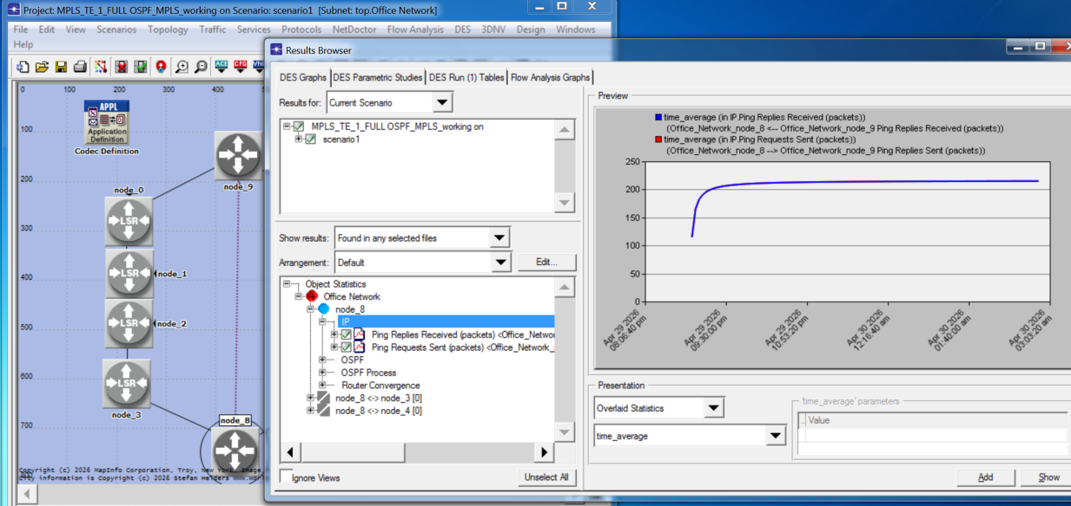
Before proceeding with any advanced configuration, it's essential to ensure that the underlying communication between the nodes is functioning correctly. Figure 3.1 shows the results of DES (Discrete Event Simulation) where ping requests were successfully sent and responses received between node_8 and node_9. This indicates that the IP layer is essentially operational and that the network is ready for MPLS implementation.

3.3 Configuring Router ID to match Loopback address
Figure (3.2): Router ID same as loopback IP for each router.
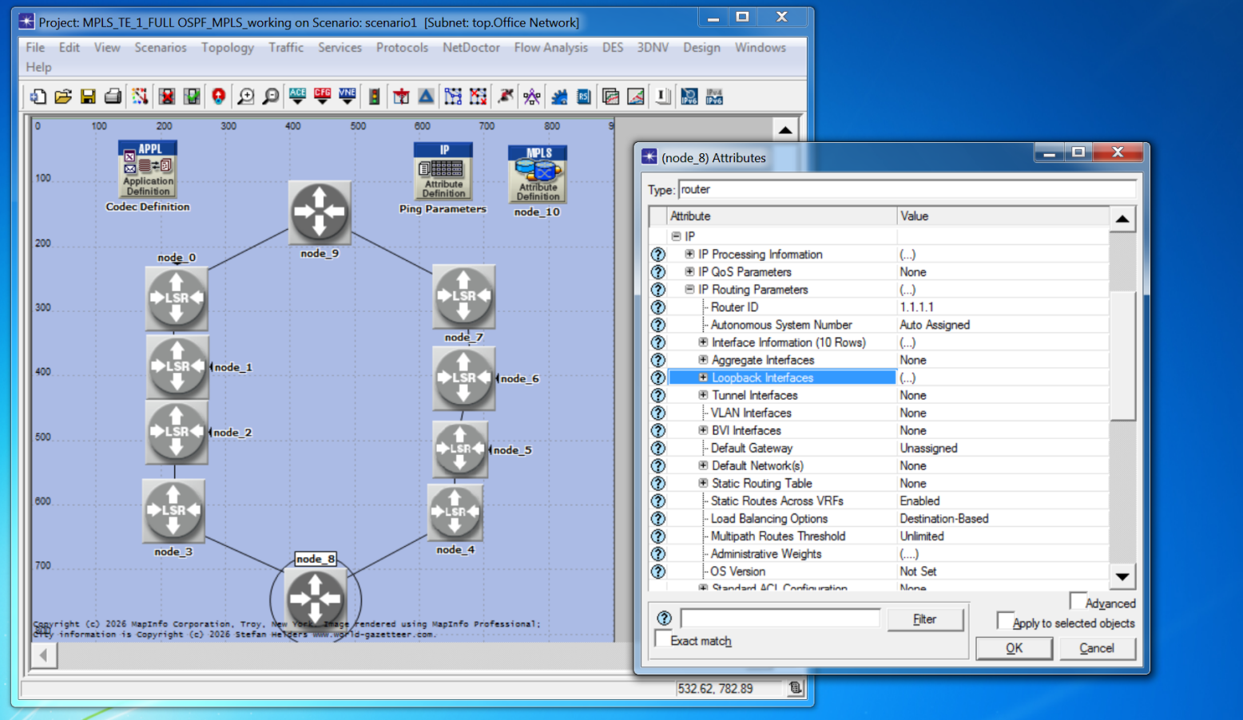
The Router ID is a unique identifier for each router within the OSPF domain. For best practices and to avoid complications, the Router ID is set to match the Loopback interface address of each device. As shown in the figure, the address 1.1.1.1 is set as the Router ID for node_8. This helps to:
Ensure the stability of the Router ID (because the Loopback rarely fails).
Easier device identification when tracing MPLS routes.

3.4 Specifying the Area ID in OSPF:
Figure (3.3): Specify the Area ID.
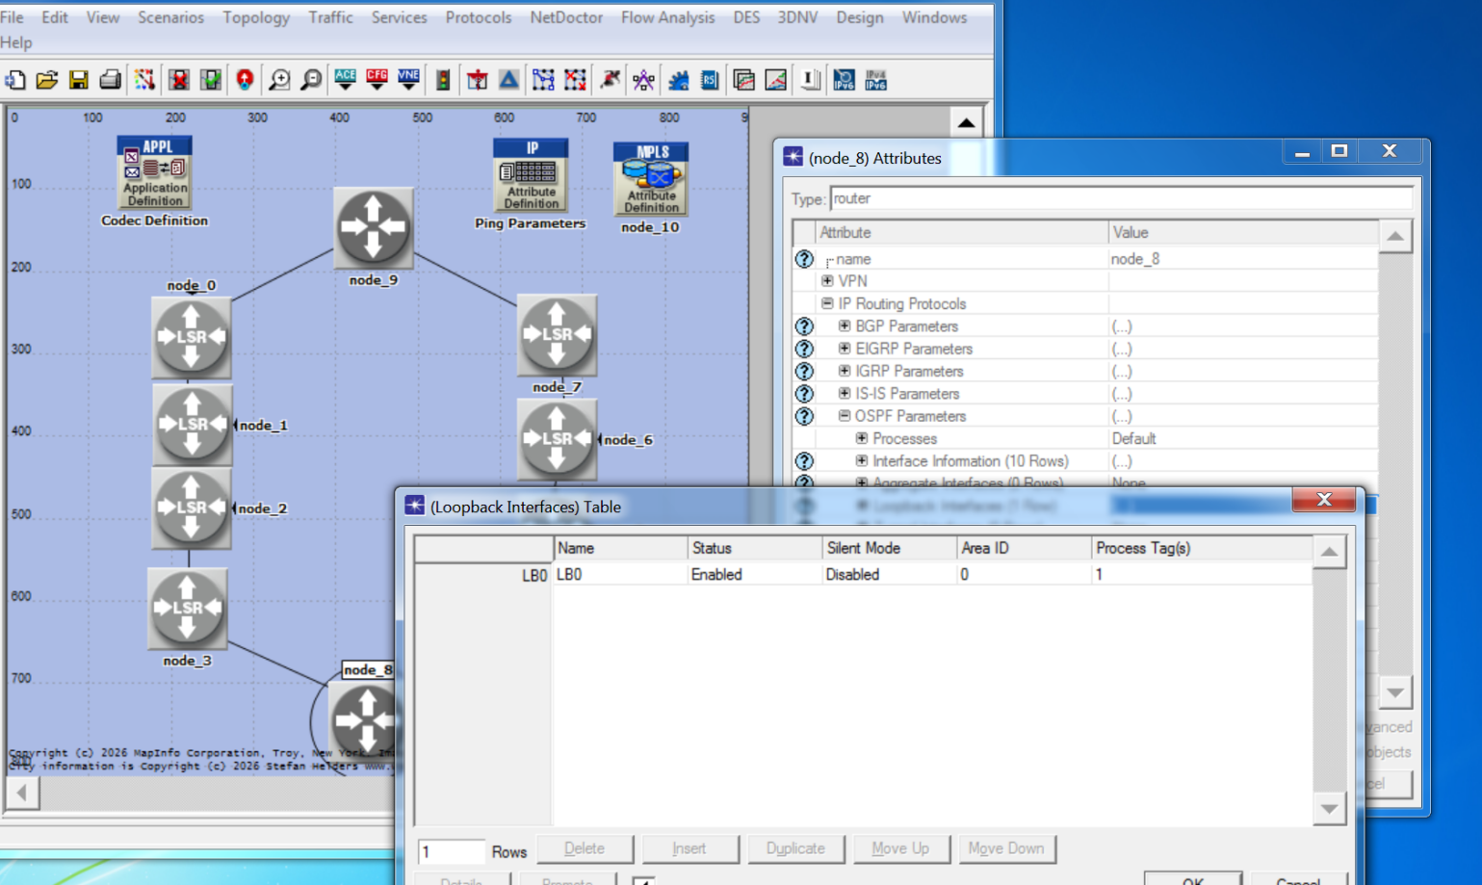
OSPF divides the network into areas to reduce table size and improve convergence speed. Figure 3.3 illustrates how to set the Area ID for the node_8 Loopback interface. In this configuration, Area ID is set to 0, which is the Backbone Area. All routers that will support MPLS must be within the same area to facilitate label distribution.

3.5 Overview of Node Attributes:
Figure (3.4): General attributes configuration.
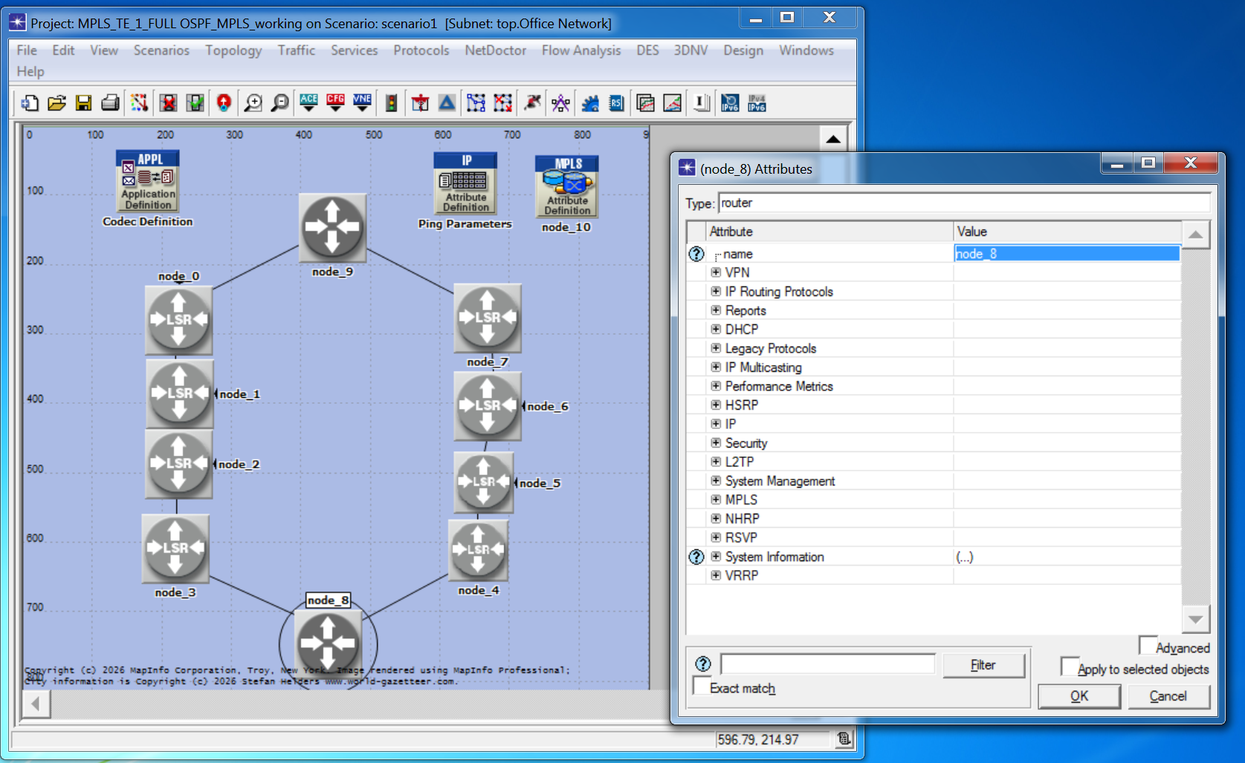

This figure shows the general settings for node_8. Note that the following options (related to MPLS) are enabled:
• IP Routing Protocols: To enable OSPF.
• MPLS: To enable label-switched multiplexing.
• RSVP: Resource reservation protocol (required for TE).
These settings are a prerequisite for enabling MPLS-TE.

3.6 Enable MPLS and LDP in general
Figure (3.5): Enable MPLS and LDP.
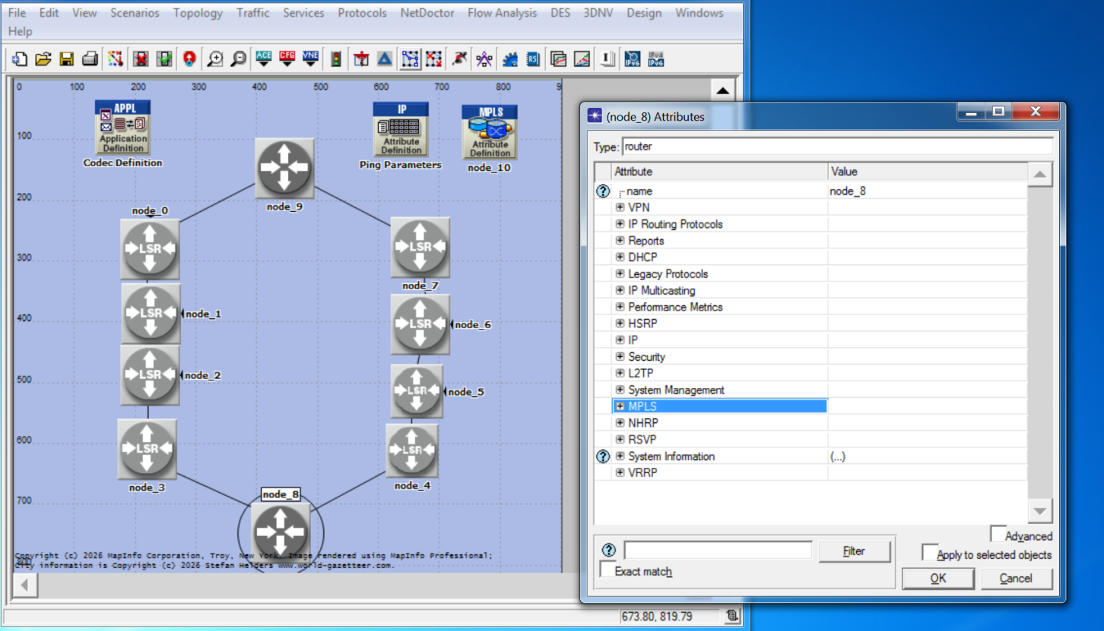
To enable MPLS on the router, go to the MPLS settings and enable the main option. As shown in the figure, this activates LDP (Label Distribution Protocol), which automatically creates a label information base (LIB) between neighboring devices. Without LDP, devices cannot exchange labels, and therefore MPLS will not function.
3.7 Configuring ICMP (Ping) messages for path testing:
Figure (3.6): ICMP messaging from node 8 to node 9.
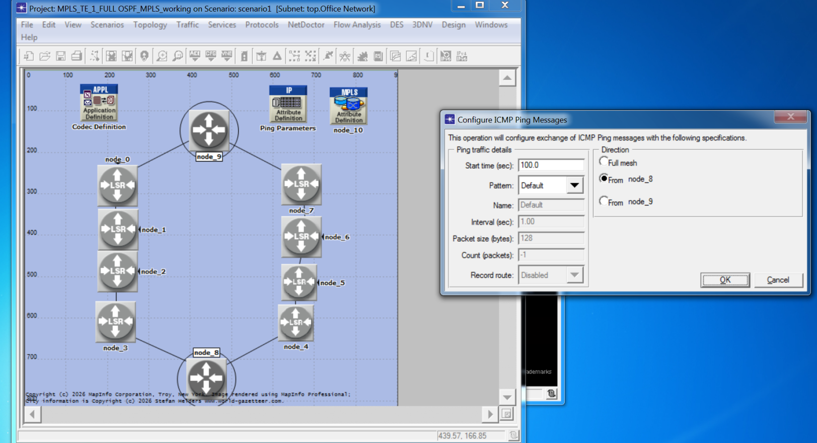

To test the MPLS path after configuration, a simple data traffic test is performed using ping. Figure 3.6 shows the ICMP message settings:
• Start time (sec): 100.0 (starts 100 seconds after the simulation begins; to allow time for OSPF and LDP to converge).
• Interval (sec): 1.00 (every second).
• Count (packets): 1 (number of packets - can be increased for higher compression).
This setting allows viewing the path taken by the packets (either via regular IP or via LSP - Label Switched Path).
3.8 Configuring IP and OSPF addresses on interfaces:
Figure (3.7): IP addressing + linkup and operational + routing OSPF.
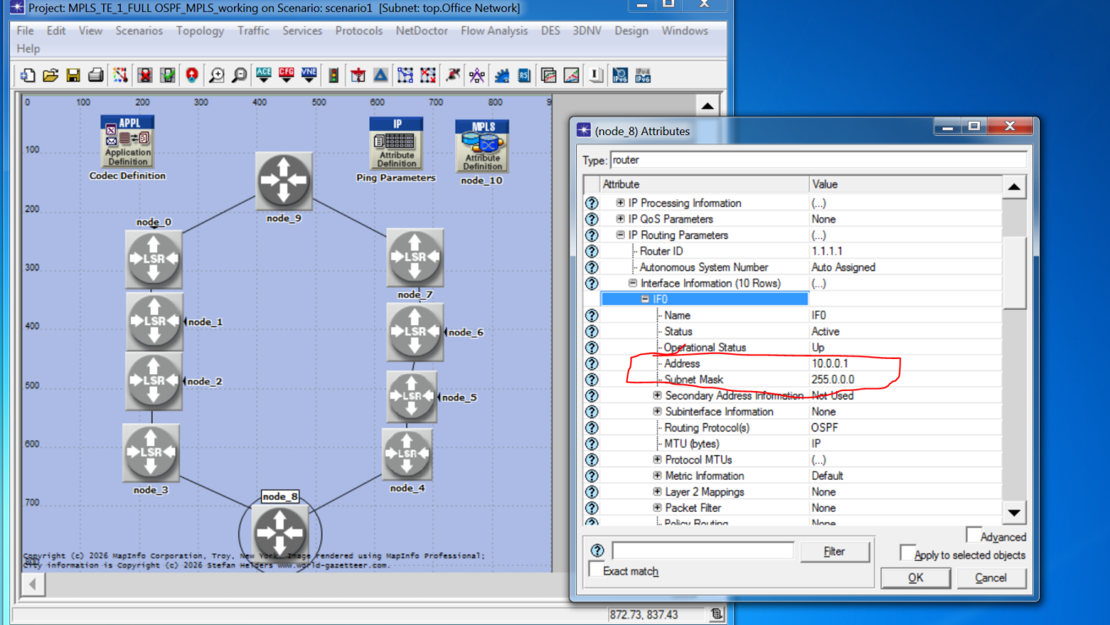
This diagram details the configuration of node_8 interfaces. The table shows:
• Status: Active.
• Operational Status: Up.
• Address: IP addresses assigned to each interface.
• Routing Protocol(s): OSPF is selected for this interface.
This ensures that OSPF will announce these subnets to neighbors.

3.9 OSPF synchronization with MPLS LDP on interfaces:
3.9 OSPF synchronization with MPLS LDP on interfaces:
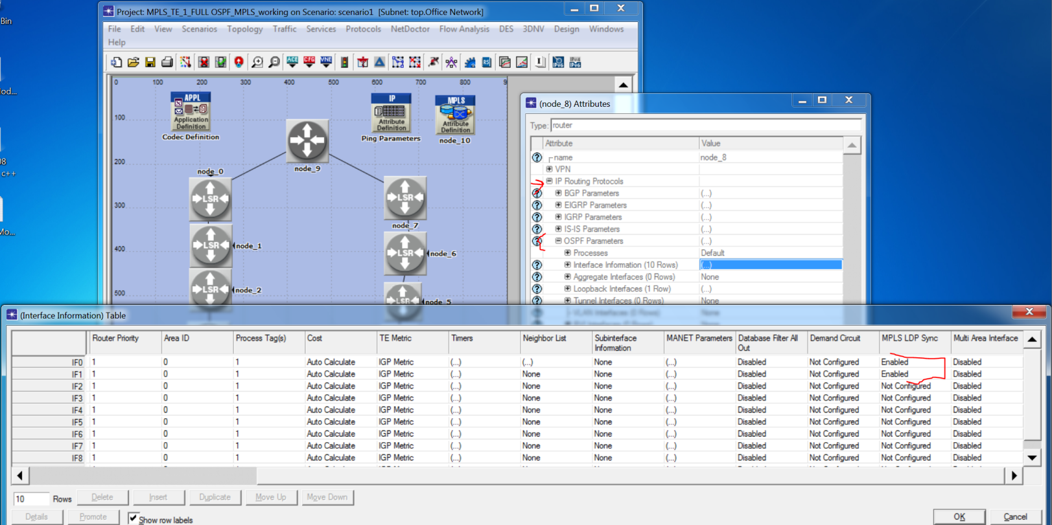
This is the most important step in integrating OSPF with MPLS. The figure shows the MPLS LDP Sync option enabled in the interface settings. What does this mean?
• Without sync: OSPF might route traffic through a path even if an LDP session hasn't yet been established on it (causing label loss and packet picking).
• With sync: OSPF will not declare a link as "available" as part of the shortest path until LDP confirms that a label exchange session on that link is working successfully.
In the figure, we see that MPLS LDP Sync is set to Enabled for all interfaces (IF0 to IF8).
3.10 Configuring and declaring Loopback interfaces in OSPF
Figure (3.9): Loopback Interfaces addressing + routing OSPF.
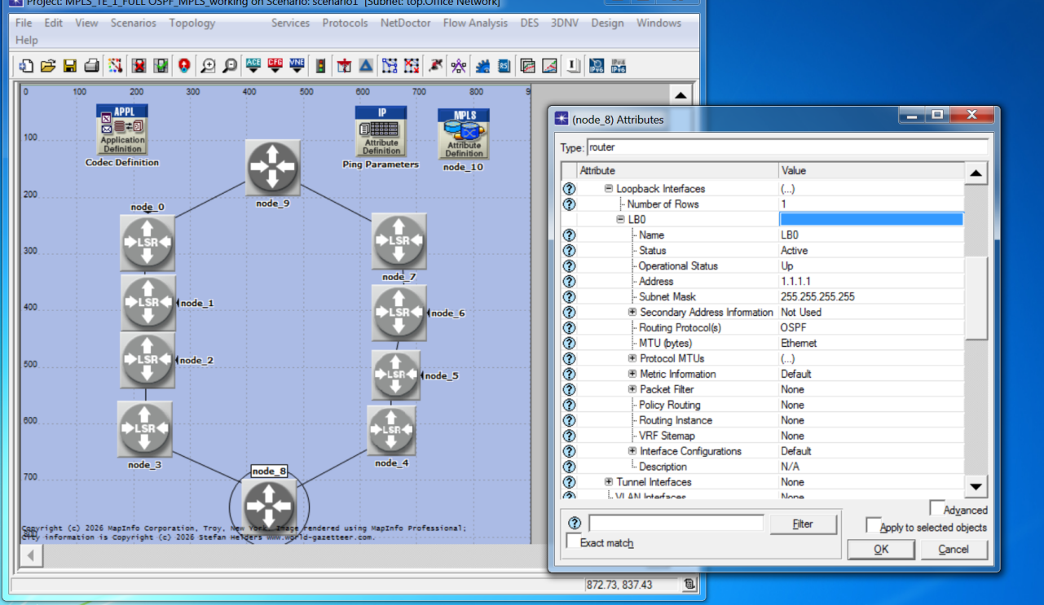
Loopback interfaces are logical (non-physical) and are considered static. Figure 3.9 illustrates their configuration: Address: 1.1.1.1 (which is the same as the Router ID). Subnet Mask: 255.255.255.255 (a /32 mask). Routing Protocol(s): OSPF (this address is declared in OSPF).
The Importance of Loopback in MPLS-TE: The Loopback address is used as the endpoint for TE tunnel routes. When TE reserves a route from node_8 to node_9, it uses their respective Loopback addresses (e.g., 1.1.1.1 to 2.2.2.2).

3.11 OSPF Convergence Monitoring:
Figure (3.10): OSPF DES showing successful convergence for node 8.
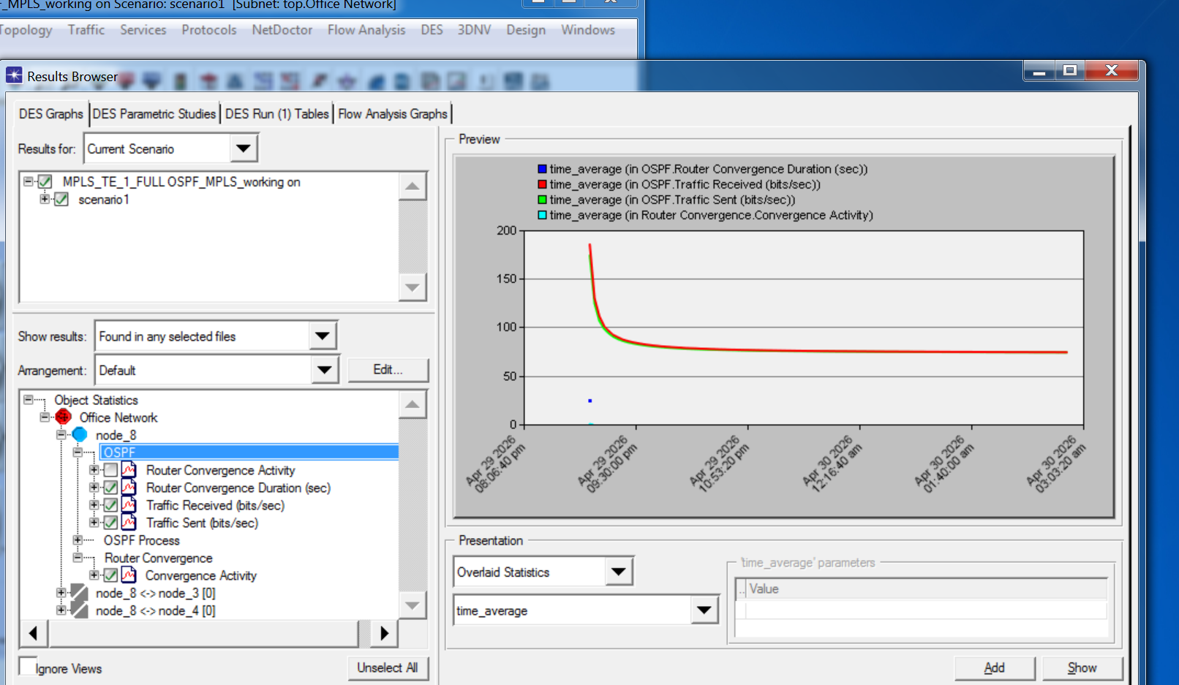
After completing all the previous configurations, the simulation (DES) is run and performance is monitored. The last figure (3.10) shows graphs of:

Router Convergence Duration (sec) – The blue line: the time it took OSPF to build the complete routing table. We note that after a short period, the value stabilized at less than 50 seconds (a good value in simulation environments).

Traffic Received/Sent (bits/sec) – The red and green lines: show OSPF traffic between devices (greetings – Hello packets and status updates – LSUs).

Conclusion: OSPF convergence is successful, meaning that all routers have the same Link Database (LSDB), and therefore MPLS-TE can begin calculating routes and allocating bandwidth.

Figure (3.11): Traffic Mapping Configuration – FEC Specifications on node_10
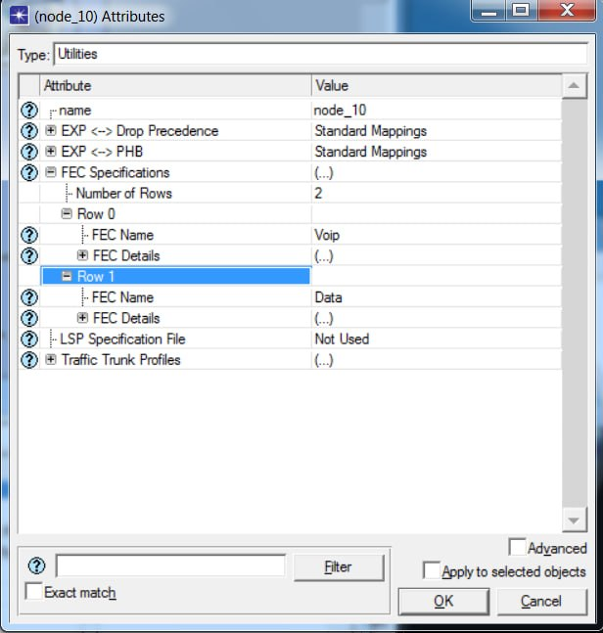

the configuration of Forwarding Equivalence Classes (FECs) for traffic classification. Two FEC rows are defined: "Voip" (high priority for voice traffic) and "Data" (lower priority for best-effort traffic). The EXP <-> PHB and EXP <-> Drop Precedence parameters are set to "Standard Mappings", ensuring QoS information is preserved in the MPLS EXP bits across the network. The LSP Specification File is set to "Not Used", indicating dynamic LSP establishment via RSVP-TE. This classification enables the application of strict priority queuing for VoIP and load balancing for data traffic, forming the foundation for effective QoS and MPLS-TE implementation.

Figure (3.12): MPLS and Traffic Engineering Attributes on node_8 (Router).
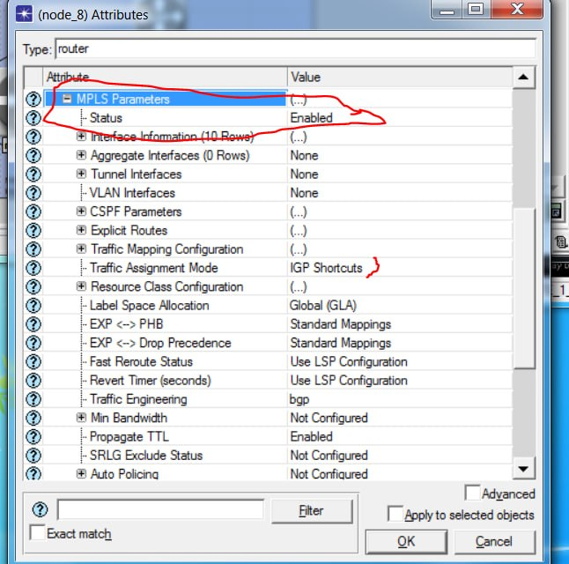

the MPLS and TE configuration parameters on node_8. MPLS Status is set to "Enabled", with Label Space Allocation configured as "Global (GLA)". The Traffic Assignment Mode is set to "IGP Shortcuts", allowing TE tunnels to be used as next-hop interfaces in IGP (OSPF) route calculations. Traffic Engineering is set to "bgp", enabling TE tunnel information distribution via BGP. EXP <-> PHB and EXP <-> Drop Precedence use "Standard Mappings" for consistent QoS handling. Fast Deroute and Revert Timer follow LSP configuration for rapid failure recovery. Propagate TTL is "Enabled" to prevent packet loops. These settings establish the router as a fully functional MPLS-TE node capable of label switching, traffic engineering, and QoS propagation.
Figure (3.13): Traffic Mapping Configuration – Interface to FEC Assignment on node_8.
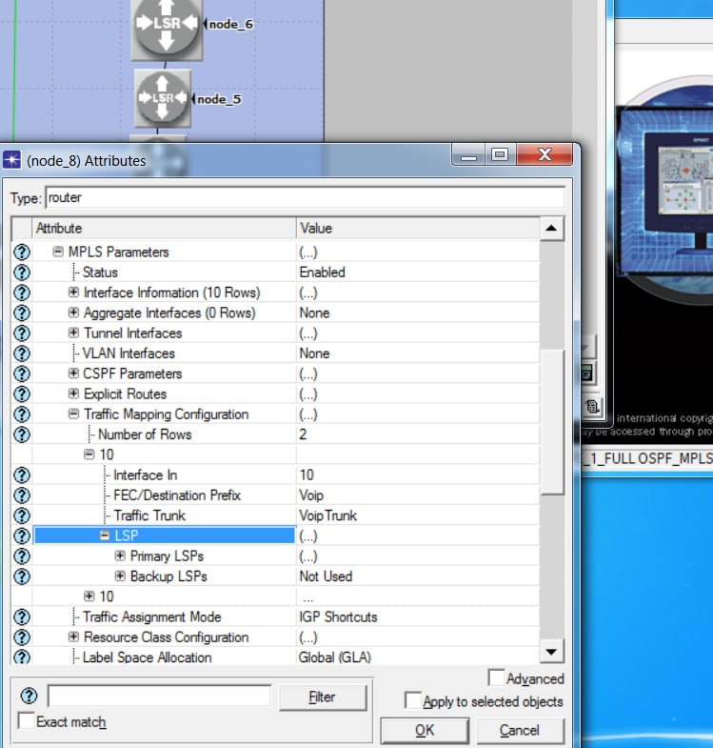

shows the binding between incoming interfaces, FECs, and Traffic Trunks on router node_8. Two mapping rows are defined, with the displayed row specifying that traffic arriving on "Interface In = 10" matching "FEC/Destination Prefix = Voip" is directed to "Traffic Trunk = VoipTrunk". The Primary LSPs field indicates the engineered tunnel assigned to carry this traffic, while Backup LSPs is set to "Not Used". This configuration ensures that VoIP traffic entering on interface 10 is mapped to the designated VoipTrunk and forwarded over the primary MPLS-TE tunnel, guaranteeing bandwidth reservation and QoS treatment for voice traffic between the two sites.
Figure (3.14): RSVP-TE Configuration on Interface IF0 of node_8.
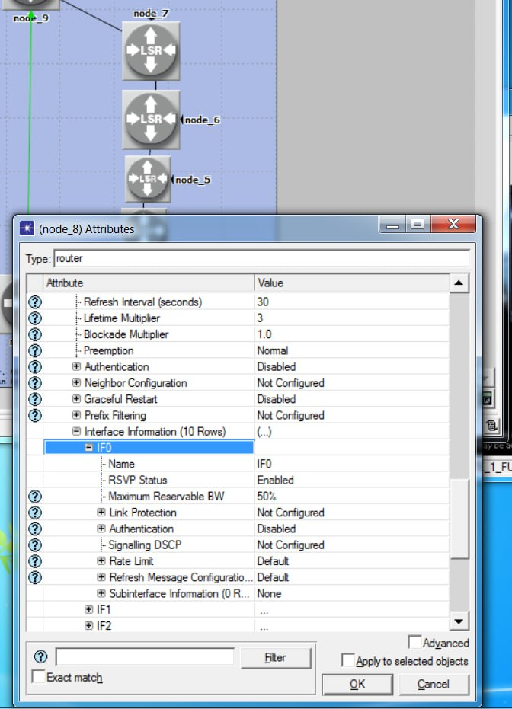

displays the RSVP-TE parameters configured on interface IF0. RSVP Status is set to "Enabled", with Maximum Reservable Bandwidth set to 50% of the link capacity for TE tunnel bandwidth allocation. The Refresh Interval is 30 seconds with a Lifetime Multiplier of 3, determining path state refresh and timeout behavior. Preemption is set to "Normal", allowing higher-priority tunnels to preempt bandwidth when necessary. Authentication and Graceful Restart are disabled, while Link Protection is not configured. These RSVP-TE settings enable the router to participate in signaling, resource reservation, and establishment of primary and secondary engineered paths between the two sites.
Figure (3.15): QoS Configuration – WFQ Profile for MPLS-TE on node_8.
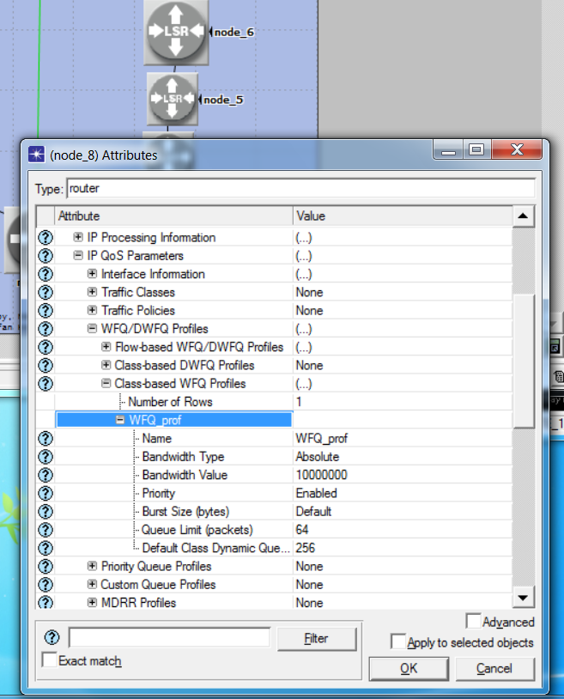

illustrates the configuration of a Weighted Fair Queuing (WFQ) profile for Quality of Service purposes. One profile named "WFQ_prof" is defined with Bandwidth Type set to "Absolute" and Bandwidth Value of 10,000,000 bps (10 Mbps). Priority is "Enabled", ensuring strict prioritization for real-time traffic. This WFQ profile is applied to the VoIP traffic class to guarantee bandwidth allocation and reduce latency for voice packets traversing the MPLS-TE tunnels between the two sites.

Figure (3.16): CPU Utilization on node_8 After MPLS-TE Activation
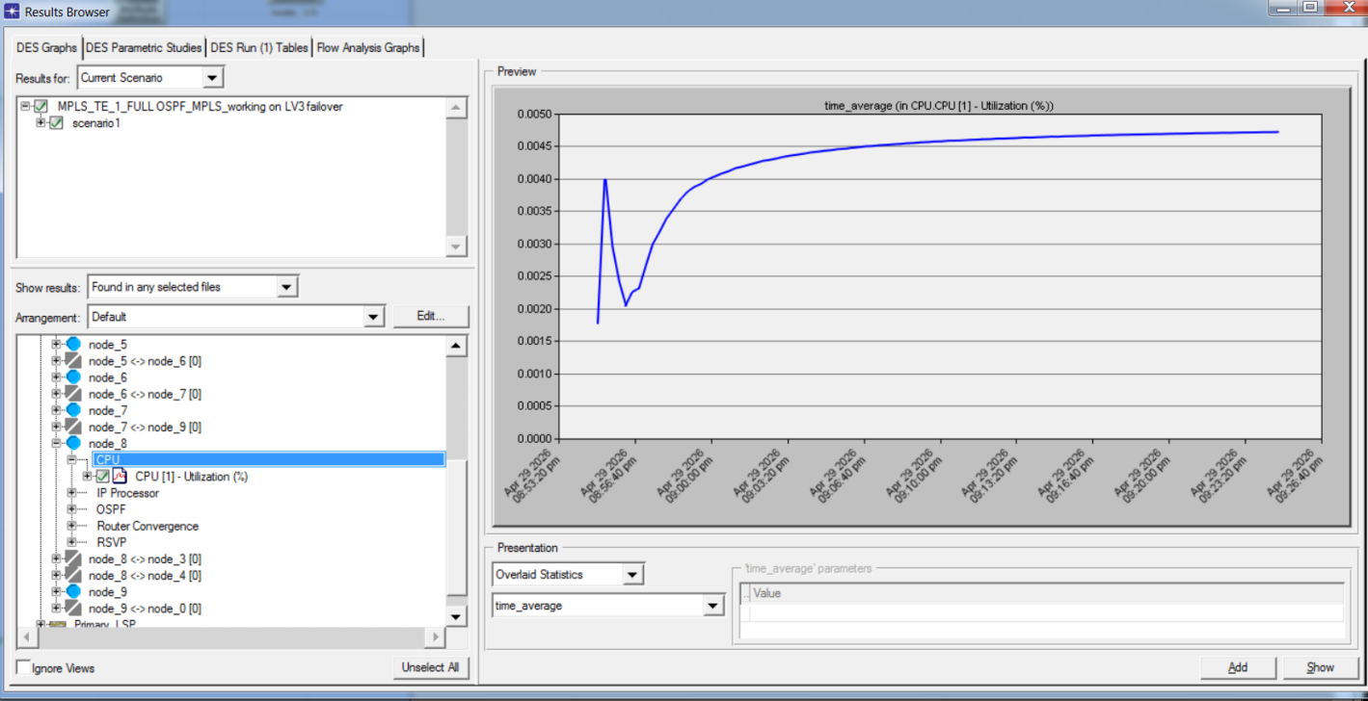
shows the CPU utilization of node_8 (core router/LSR) after enabling MPLS-TE, OSPF, and RSVP. The graph displays a stable and low average CPU usage ranging between 0.0015% and 0.0045%. This indicates that MPLS-TE operations, including label switching and RSVP signaling, impose minimal processing overhead on the router. Neighboring nodes show similarly low utilization levels, confirming the efficiency and feasibility of the proposed secure network architecture.

Figure (3.17): CPU Utilization on node_9 After MPLS-TE Activation
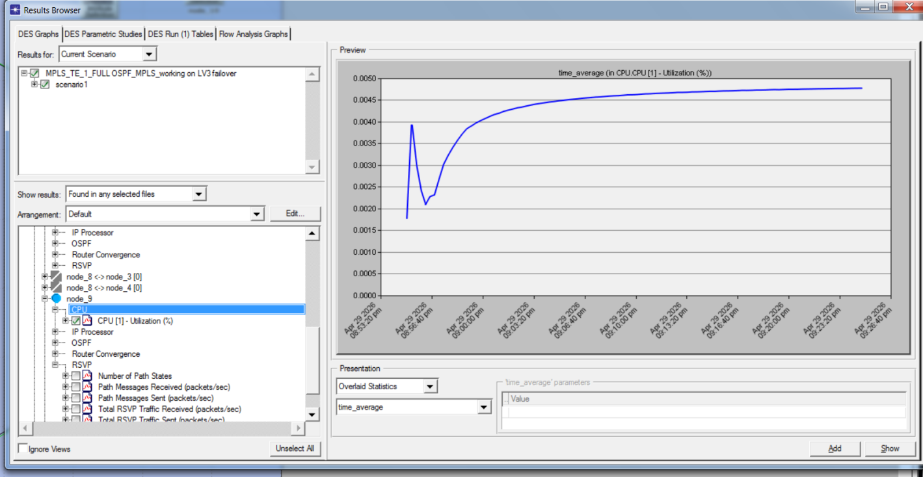
This figure shows the CPU utilization of node_9 (core router/LSR) after enabling MPLS-TE, OSPF, and RSVP. The graph displays stable and low average CPU usage ranging between approximately 0.001% and 0.004%. This confirms that MPLS-TE operations, including label switching, RSVP signaling, and OSPF convergence, impose minimal processing overhead on the router, similar to node_8. These results validate the efficiency and feasibility of the proposed secure network architecture across multiple core nodes.

Figure (3.18) : Delay on Primary Link
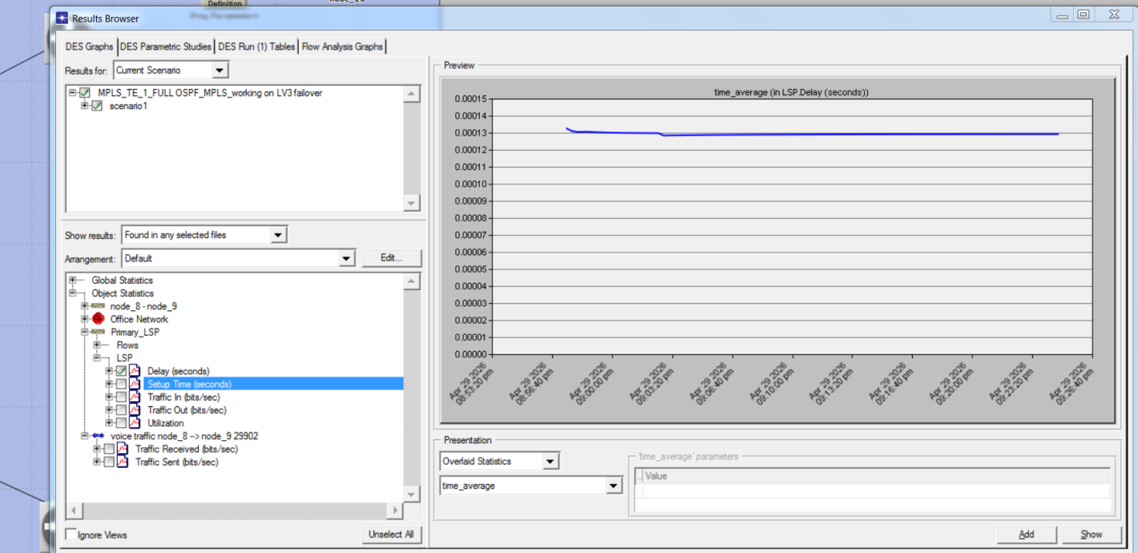
This figure illustrates the time-average delay measured on the primary MPLS-TE link between node_8 and node_9 within the OPNET Modeler 14.5 simulation environment. The graph shows a consistently stable delay throughout the simulation period, remaining within a very narrow microsecond range, which indicates that the primary engineered path maintained high performance with no signs of congestion or fluctuation. This stability confirms the effectiveness of the MPLS-TE configuration in ensuring a reliable low-latency route suitable for real-time traffic.

Figure (3.19) : Delay on Secondary Link After MPLS-TE Activation
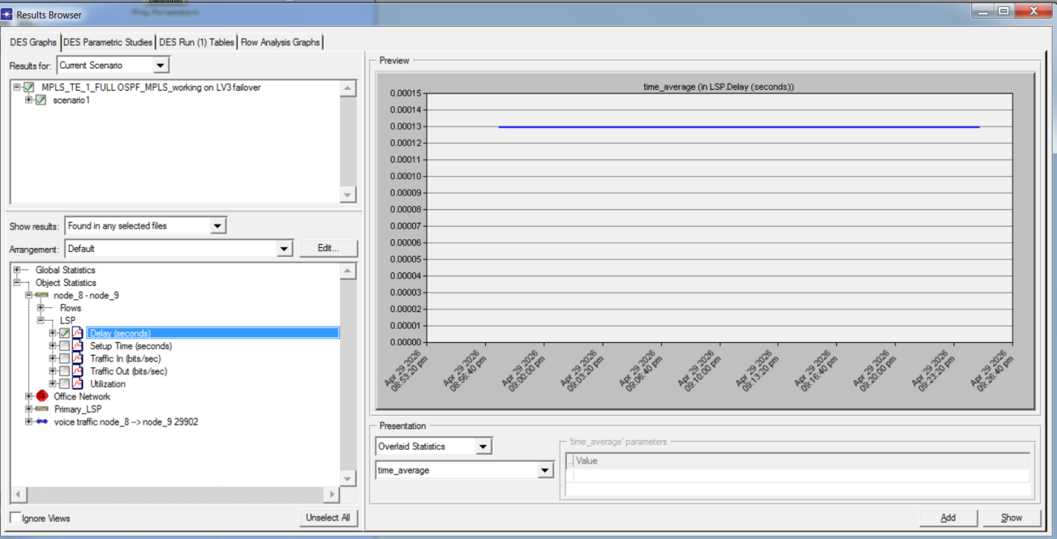

shows the LSP delay in seconds on the secondary path between node_8 and node_9 after enabling MPLS-TE. The graph displays a stable and very low average delay ranging between approximately 0.00001 and 0.00015 seconds. This confirms that the secondary engineered path provides acceptable latency for voice traffic, ensuring reliable failover and load balancing capabilities within the proposed secure network architecture

Figure (3.20) : Primary LSP Flow Traffic Between node_8 and node_9
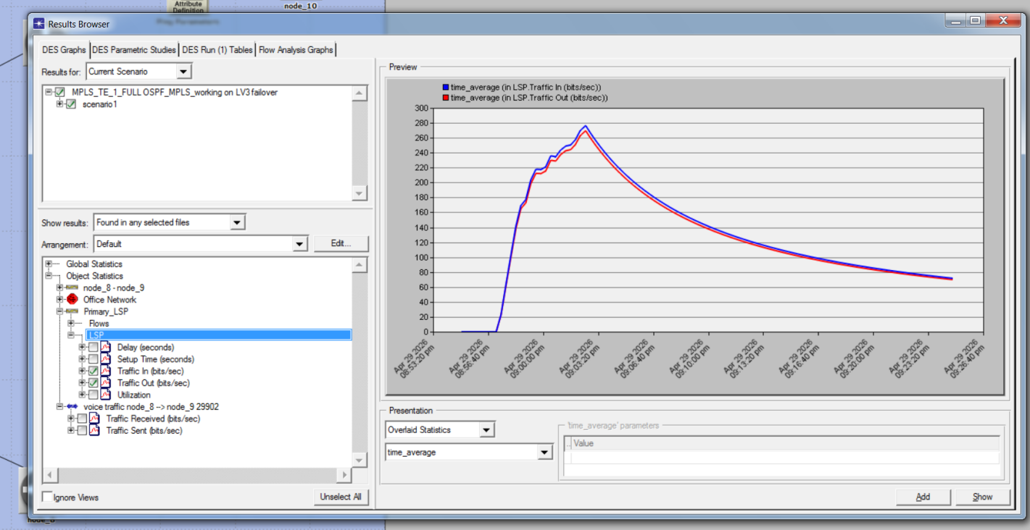
shows the traffic statistics for the primary LSP carrying voice traffic from node_8 to node_9 after MPLS-TE activation. The monitored metrics include Traffic Received and Traffic Sent (bits/sec), along with delay, setup time, and utilization. The results confirm that the primary engineered path is successfully carrying classified VoIP traffic with the configured bandwidth reservation via RSVP-TE, ensuring reliable end-to-end voice communication between the two sites

Figure (3.21) : Secondary LSP Flow Traffic Between node_8 and node_9
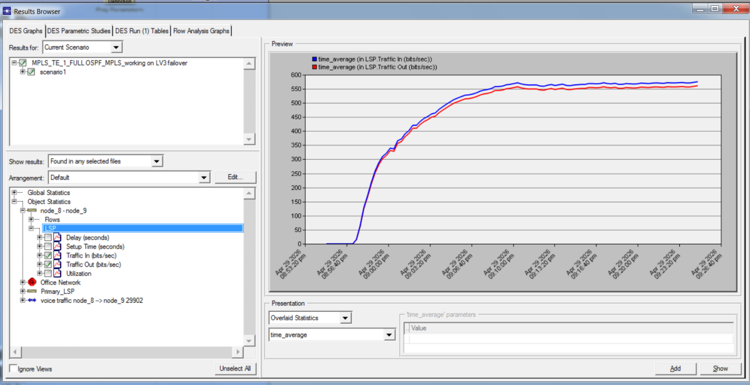
shows the traffic statistics for the secondary LSP carrying voice traffic from node_8 to node_9 after MPLS-TE activation. The graph displays the time_average LSP Traffic In ranging between approximately 50 and 600 bits/sec. This confirms that the secondary engineered path is successfully carrying classified traffic with load balancing capabilities, ensuring reliable failover and backup connectivity between the two sites

Figure (3.22) : RSVP Path Messages Received on node_9
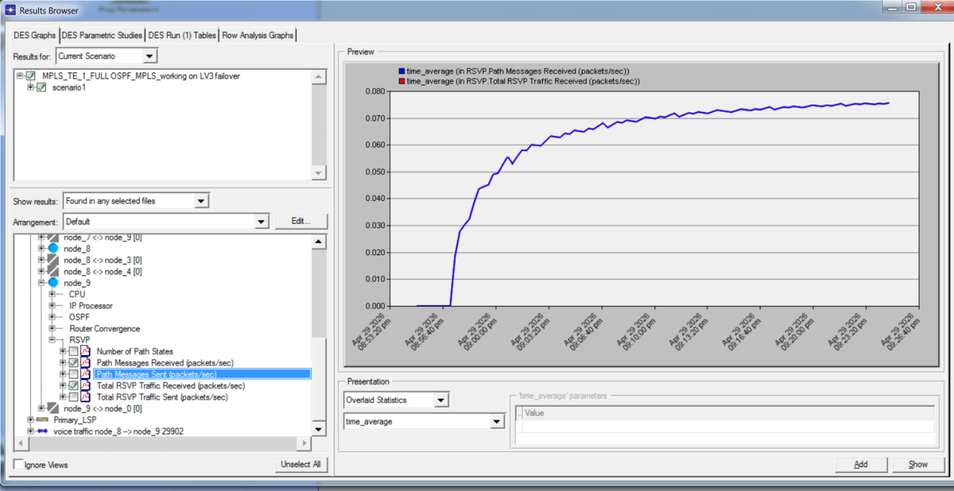

the RSVP Path Messages Received (packets/sec) on node_9 after MPLS-TE activation. The graph displays the time_average RSVP traffic received, confirming that RSVP signaling protocol is successfully operating to reserve bandwidth and establish engineered paths between the two sites. This validates the proper functioning of RSVP-TE for primary and secondary LSP setup

Figure (3.23) : RSVP Path Messages Sent from node_8
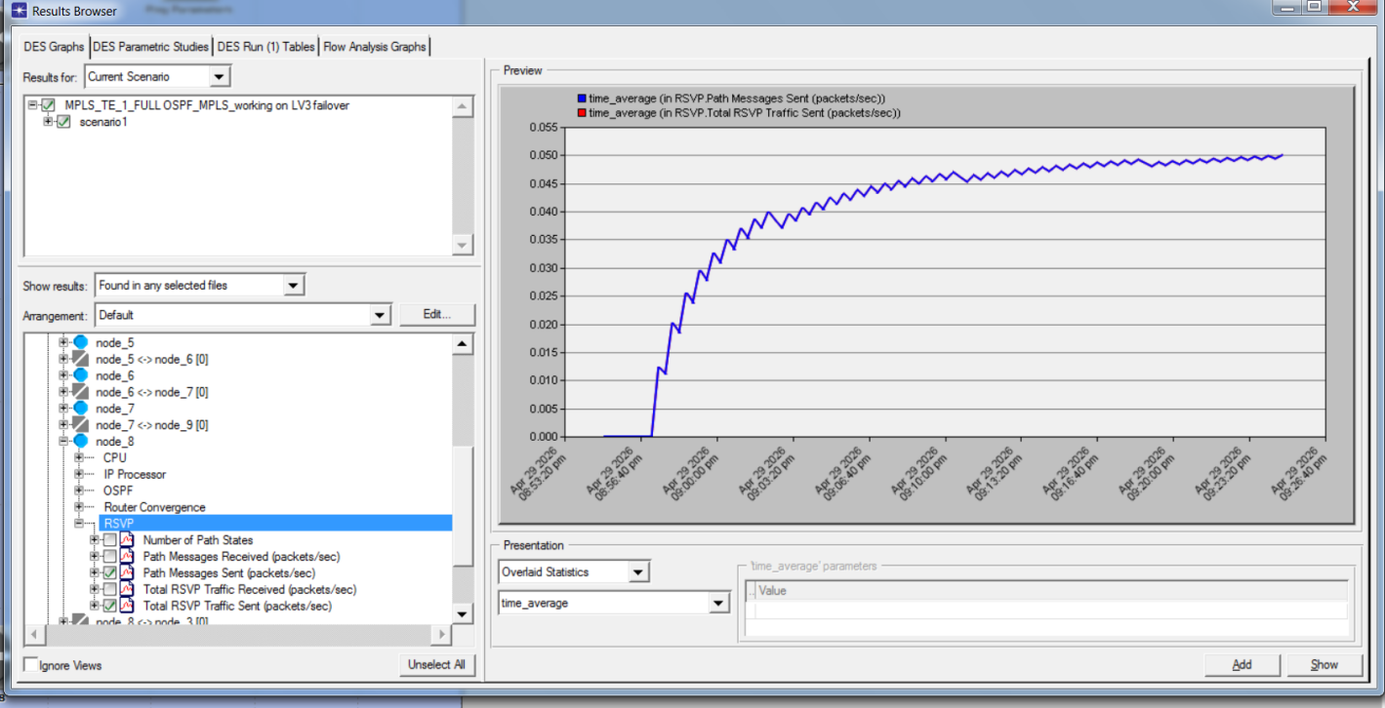

shows the RSVP Path Messages Sent (packets/sec) from node_8 after MPLS-TE activation. The graph displays the time_average RSVP traffic sent ranging between approximately 0.005 and 0.055 packets/sec. This confirms that node_8 is actively participating in RSVP signaling to establish and maintain engineered tunnels, enabling bandwidth reservation and QoS guarantees for voice traffic traversing the secure site-to-site network.

Figure (3.24) : Throughput on Link Between node_7 and node_9

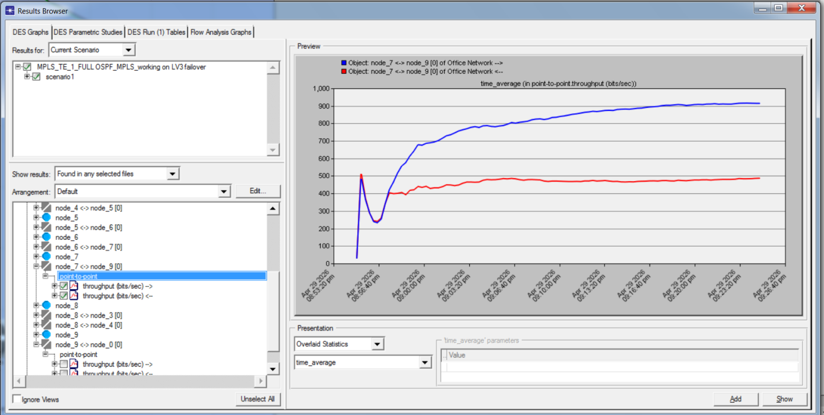

presents the throughput behavior on the point‑to‑point link connecting node_7 and node_9 within the MPLS‑TE simulation scenario. The graph displays the time‑average throughput in both directions over the duration of the experiment. The blue curve, representing the outbound traffic from node_7 toward node_9, shows a gradual increase from approximately 500 bits per second to around 850 bits per second, indicating rising load on the forward path as the simulation progresses. In contrast, the red curve, representing the inbound traffic toward node_7, remains relatively stable near 400 bits per second with minimal fluctuation. This clear asymmetry between the two directions reflects the nature of the traffic pattern on this link and demonstrates that the MPLS‑TE configuration maintained consistent throughput without signs of congestion or instability

Figure (3.25) Traffic Sent and Received on Secondary Link
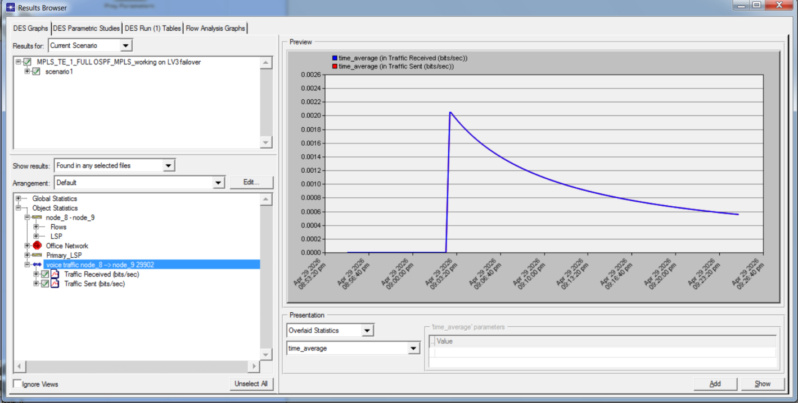
the time_average Traffic Sent and Traffic Received (bits/sec) on the secondary LSP between node_8 and node_9 after MPLS-TE activation. The graph displays stable values ranging between approximately 0.0002 and 0.0026 bits/sec. This confirms that the secondary engineered path is successfully carrying traffic with load balancing capabilities, ensuring reliable failover and backup connectivity between the two sites

Figure (3.26) : Traffic Sent and Received on Primary Link
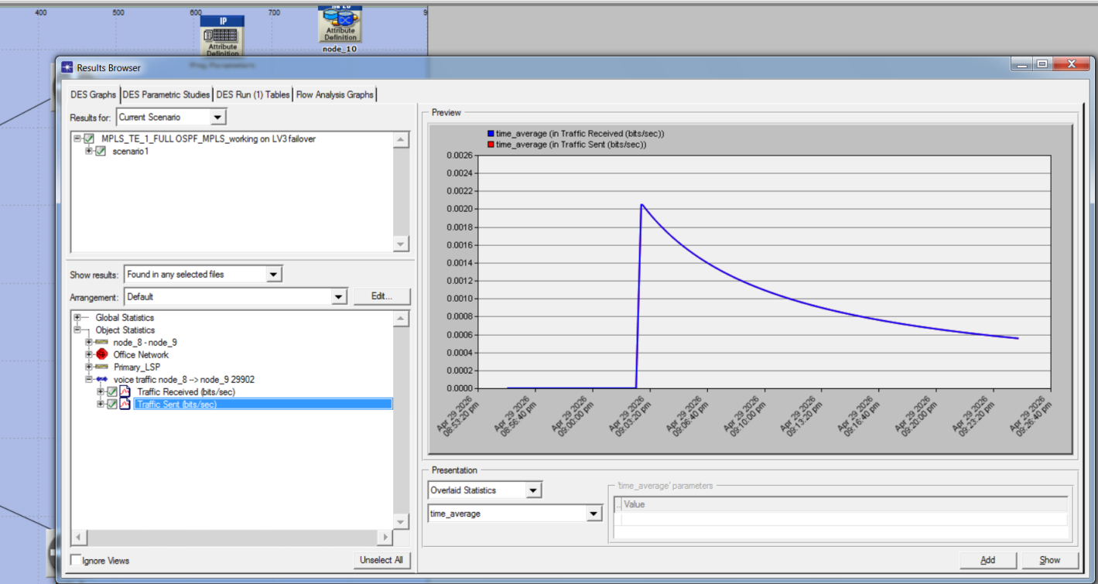
the time_average Traffic Sent and Traffic Received (bits/sec) on the primary LSP for voice traffic from node_8 to node_9 after MPLS-TE activation. The results confirm that the primary engineered path is successfully carrying classified VoIP traffic with stable throughput, ensuring reliable end-to-end voice communication between the two sites with the configured bandwidth reservation via RSVP-TE

Figure (3.27) : IPsec Encryption Algorithm Configuration (AES)
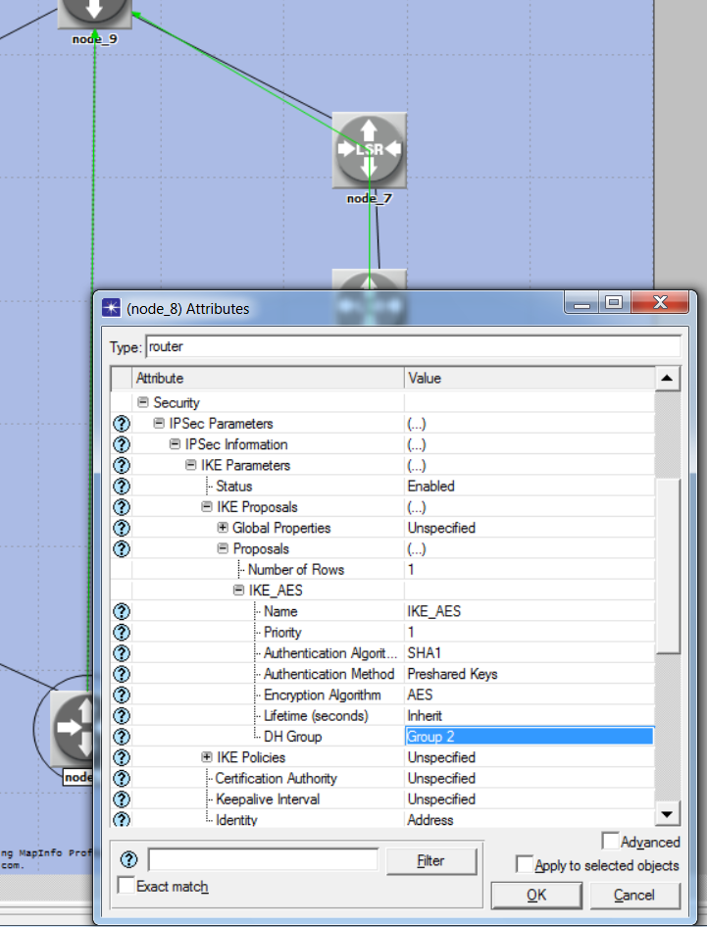..
the IKE Phase 1 configuration on node_8, where the Encryption Algorithm is set to AES. This defines how the control channel is encrypted to protect negotiation messages. The IKE proposal "IKE_AES" also specifies Authentication Algorithm as SHA1, Authentication Method as Preshared Keys, and DH Group as Group 2 for secure key exchange

Figure (3.28) IPsec Transform Set Configuration (ESP Tunnel Mode)
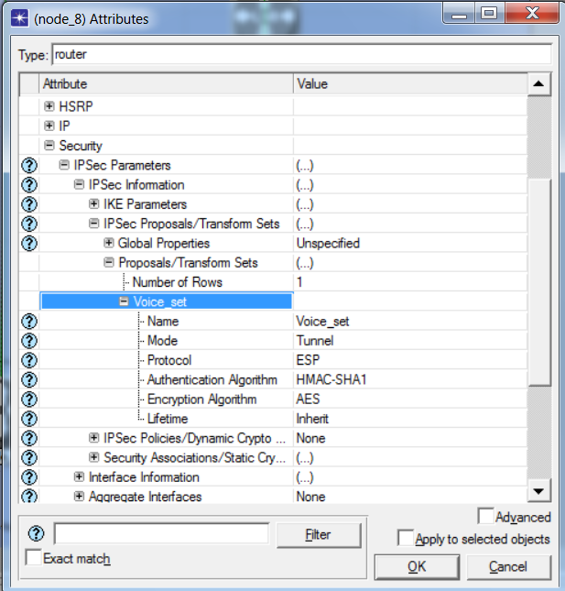.
the IKE Phase 1 Policy configuration on node_8. The policy defines Remote Peer Address as 16.0.0.1, Mode as Main, IKE Proposals as IKE_AES, Authentication Method as Preshared Keys (PSK), and Authentication Key as "mpls_secret". This enables peer authentication and secure key exchange before establishing the encrypted tunnel

Figure (3.29) IPsec Tunnel Establishment and Peer Configuration
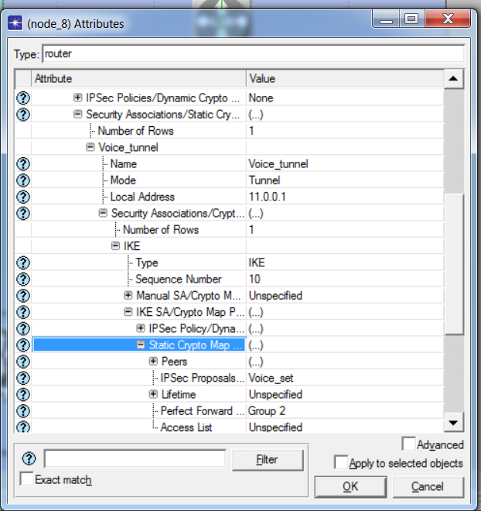.
the Security Associations/Static Crypto configuration on node_8. The "Voice_tunnel" defines Mode as Tunnel, Local Address as 11.0.0.1, and references the "Voice_set" IPSec Proposals. This establishes the IPSec Security Association (IPsec SA) between the LER routers to secure user payload traffic

Figure (3.30) : IKE Policy and Pre-shared Key Configuration
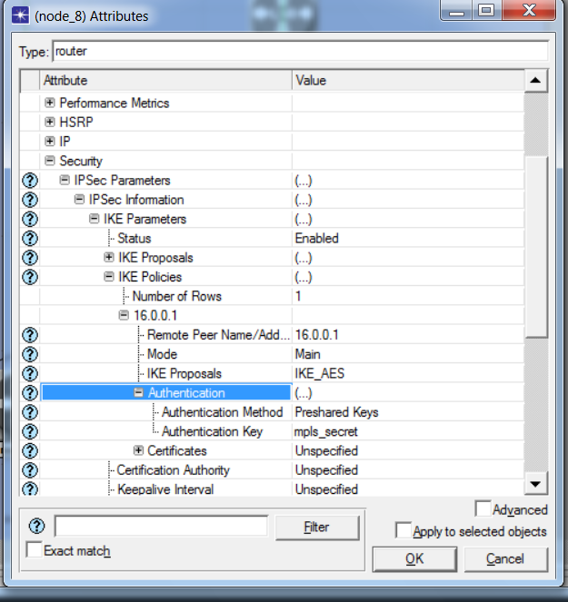

the simulation results for voice traffic between node_8 and node_9 after enabling IPsec encryption alongside MPLS-TE. The monitored statistics include Traffic Received/Sent (bits/sec), Delay, Setup Time, and Utilization. The results confirm that the IPsec tunnel (using ESP with AES encryption) successfully encrypts all VoIP traffic between the two sites, rendering it unreadable upon interception while maintaining acceptable performance over the MPLS-TE infrastructure
Figure (3.31) : Overall IPsec-Encrypted Traffic Results
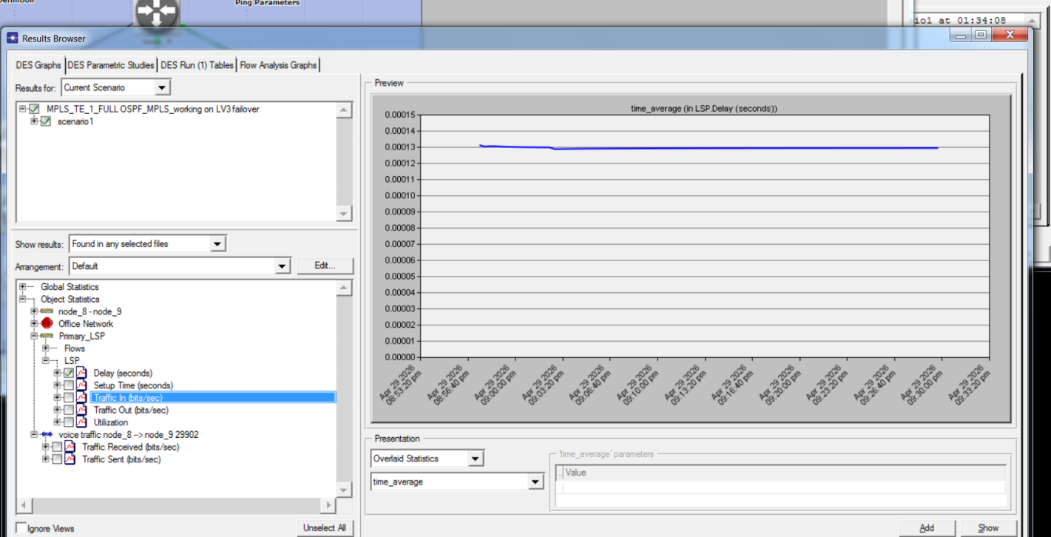

. the simulation results for voice traffic between node_8 and node_9 after enabling IPsec encryption alongside MPLS-TE. The monitored statistics include Traffic Received/Sent (bits/sec), Delay, Setup Time, and Utilization. Although the IPsec tunnel (using ESP with AES encryption) , the results are neither logical nor satisfactory, as the displayed values are very close to the baseline values (before IPsec activation). This is likely due to the added delay introduced by encryption processes, hashing operations, and IKE session establishment (Phase 1 and Phase 2 negotiations), which should normally impact performance metrics. The fact that these overheads are not visibly reflected in the results suggests possible simulation limitations or within OPNET

4.1 Chapter Four: Comparisons and Analysis

4.1.1 Analysis of Achieved Results

This chapter aims to provide a comprehensive analysis of the results obtained after implementing and configuring the secure network between the two sites using MPLS-TE, QoS, and IPsec technologies in the OPNET Modeler 14.5 simulation environment. The focus is on the extent to which the project achieved its planned objectives, comparing network performance under different scenarios (with or without MPLS, with or without QoS, and with or without IPsec). A summary of the team's achievements and challenges is also presented, along with recommendations and future directions for project development.

This chapter offers a brief comparison between the OPNET Modeler 14.5 and NS-3 simulation tools, explaining the reasons for choosing OPNET for this project. It also provides a quick analysis of the results obtained from the simulation images included in Chapter 3.

4.2 Comparison between OPNET and NS-3
Standard | OPNET Modeler 14.5 | NS-3
User interface | Graphical User Interface (GUI) – Easy and Fast | Command line + programming (C++/Python)
Ease of learning | Advanced | Difficult, requires programming expertise
MPLS/MPLS-TE support | Fully integrated (ready) | Limited, requires additions or programming
Advanced OSPF support | Complete (areas, various facades) | Basic and limited
IPsec support and encryption | Powered by Features | Not natively supported, requires additional packages
Show results | Ready-made charts | External programming is required (Python/matplotlib).
Preparation time | Fast (hours - days) | Slow (weeks - months)
Licensing | Commercial (paid) | Open source (free)
Suitable for | University projects, Master's degrees, engineers | PhD researchers, protocol developers

4.2.1 OPNET Advantages and Disadvantages
Disadvantages | Features
Commercial (paid) program | Integrated graphical interface (drag-and-drop)
Not open source | Native integration of MPLS, LDP, RSVP-TE, QoS, IPsec
Limited support for modern libraries | Speed ​​in building and modifying the simulation
- | Ready-made reports and charts
- | Suitable for academic and engineering projects
4.2.2 NS-3 Advantages and Disadvantages
Disadvantages | Features
There is no graphical interface (command line only). | Open source (completely free)
Experience with C++/Python is required. | High flexibility in modification and programming
Poor or no support for MPLS-TE and IPsec | An active community and continuous updates
Long time to develop simulation | Suitable for advanced scientific research
Difficulty in debugging | -
Figure : Capturing LSP Flows and Traffic Statistics.
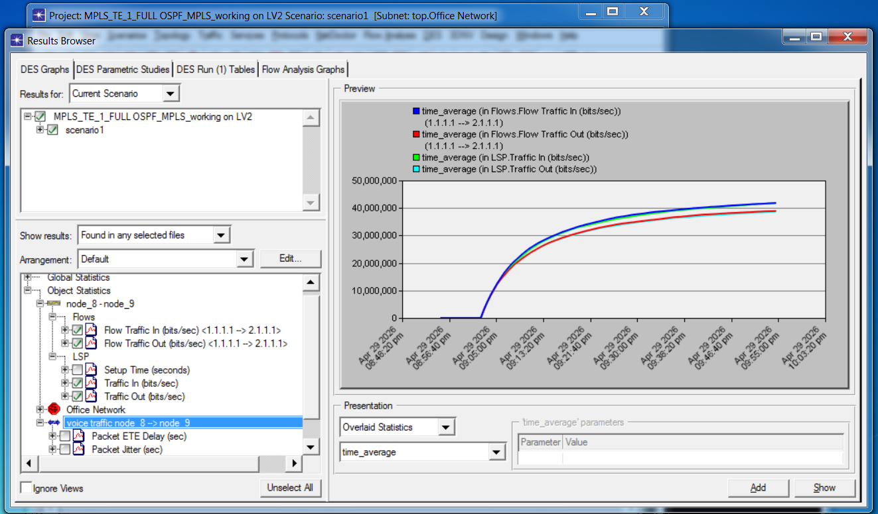
displays the Results Browser in OPNET for monitoring MPLS-TE traffic flows. Key statistics include Flow Traffic In/Out (bits/sec) between source (1.1.1.1) and destination (2.2.2.2), LSP Traffic In/Out (bits/sec), Packet ETE Delay (sec), and Packet Jitter (sec) for voice traffic. The graph shows a time axis from April to December 2026 with Y-axis ranging from 0 to 50,000,000 bits/sec. These statistics enable performance analysis of the primary and secondary LSPs, including throughput measurement, delay verification for VoIP QoS compliance, and jitter monitoring. The captured data validates that the MPLS-TE tunnels are successfully carrying classified traffic between the two sites with the configured bandwidth reservations.

Figure : VoIP Packet Simulation After MPLS-TE Activation.
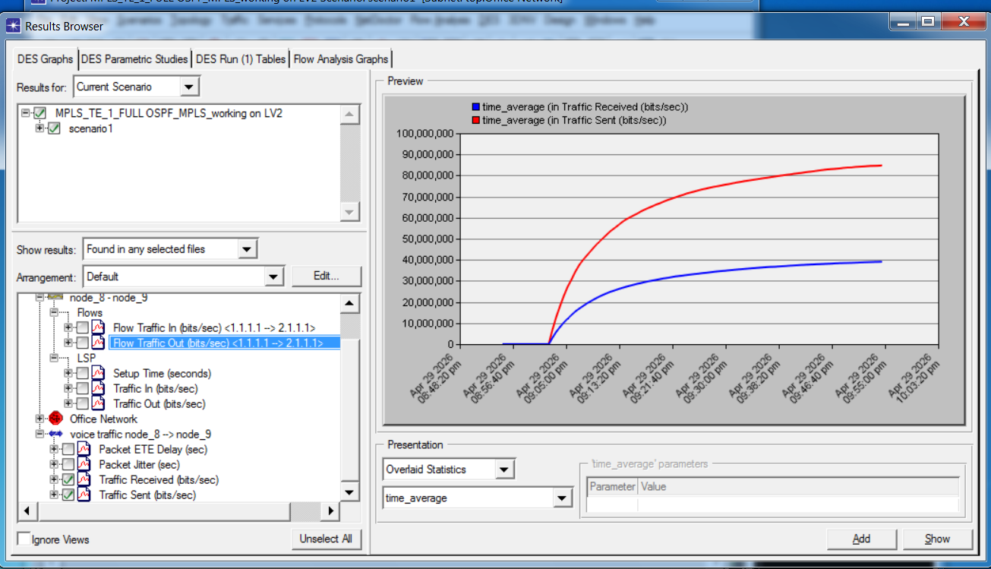
presents the simulation results for VoIP traffic after enabling MPLS-TE on the network. Key monitored statistics include Flow Traffic In/Out (bits/sec) between source (1.1.1.1) and destination (2.1.1.1), LSP Traffic In/Out (bits/sec), and critical VoIP performance metrics including Packet ETE Delay (sec), Packet Jitter (sec), and Traffic Received/Sent (bits/sec) for voice traffic between node_8 and node_9. These measurements verify that VoIP packets are successfully traversing the MPLS-TE tunnels with the configured QoS policies (strict priority queuing and bandwidth reservation via RSVP-TE), ensuring acceptable end-to-end delay and minimal jitter for real-time voice communication across the secure site-to-site network.

Reference :
[1] E. Rosen et al., "Multiprotocol Label Switching Architecture," IETF RFC 3031, 2001.
[2] B. Davie and Y. Rekhter, "MPLS: Technology and Applications," Morgan Kaufmann Publishers, 2000.
[3] L. De Ghein, "MPLS Fundamentals," Cisco Press, 2007.
[4] A. Farrel et al., "A Path Computation Element (PCE)-Based Architecture," IETF RFC 4655, 2006.
[5] D. Awduche et al., "Requirements for Traffic Engineering Over MPLS," IETF RFC 2702, 1999.
[6] J. Moy, "OSPF Version 2," IETF RFC 2328, 1998.
[7] A. Retana et al., "OSPF Stub Areas and Not-So-Stubby Areas (NSSA)," IETF RFC 3101, 2003.
[8] T. Szigeti and C. Hattingh, "End-to-End QoS Network Design," Cisco Press, 2004.
[9] L. Martini et al., "Encapsulation Methods for Transport of Ethernet over MPLS Networks," IETF RFC 4448, 2006.
[10] S. Bryant and P. Pate, "Pseudo Wire Emulation Edge-to-Edge (PWE3) Architecture," IETF RFC 3985, 2005.
[11] S. Khan et al., "Performance Evaluation of MPLS Networks with QoS," International Journal of Computer Networks, 2019.
[12] A. Al-Saadi and H. Al-Raweshidy, "Improving MPLS Traffic Engineering Using OSPF Extensions," Journal of Network Systems, 2020.
[13] E. Mulyana et al., "Implementation of MPLS and OSPF on RouterOS for Site-to-Site Connectivity," International Journal of Advanced Computer Science, 2021.
[14] K. Myers, "MPLS Network Design and Implementation for WISPs," MikroTik MUM Presentation, 2025.
[15] Network Berg, "Configuring MPLS VPN Services on MikroTik RouterOS v7," Class Central, 2025.
[16] L. Andersson, I. Minei, and B. Thomas, LDP Specification, IETF RFC 5036, October 2007.
[17] I. F. N. Calderaro, P. H. Guyss, and F. M. de Almeida, "Security of Information and IPSEC VPN," in O universo das ciências exatas e da terra: teoria e aplicações 2, 2024, ch. 1, pp. 1–17.

